Salesforce

Introduction:

Are you new to Salesforce? Not sure exactly what it is, or how to use it? Don’t know

where you should start on your learning journey? If you’ve answered yes to any of

these questions, then you’re in the right place. This module is for you.

Welcome to Salesforce! Salesforce is game-changing technology, with a host of

productivity-boosting features, that will help you sell smarter and faster. As you

work toward your badge for this module, we’ll take you through these features and

answer the question, “What is Salesforce, anyway?”.

What Is Salesforce?

Salesforce is your customer success platform, designed to help you sell, service,

market, analyze, and connect with your customers.

Salesforce has everything you need to run your business from anywhere. Using

standard products and features, you can manage relationships with prospects and

customers, collaborate and engage with employees and partners, and store your

data securely in the cloud.

So what does that really mean? Well, before Salesforce, your contacts, emails,

follow-up tasks, and prospective deals might have been organised something like

this:

<https://youtu.be/r9EX3lGde5k>

# MILESTONE-1

# Creating Developer Account

Creating a developer org in salesforce.

1. Go to https://developer.salesforce.com/signup

2. On the sign up form, enter the following details :

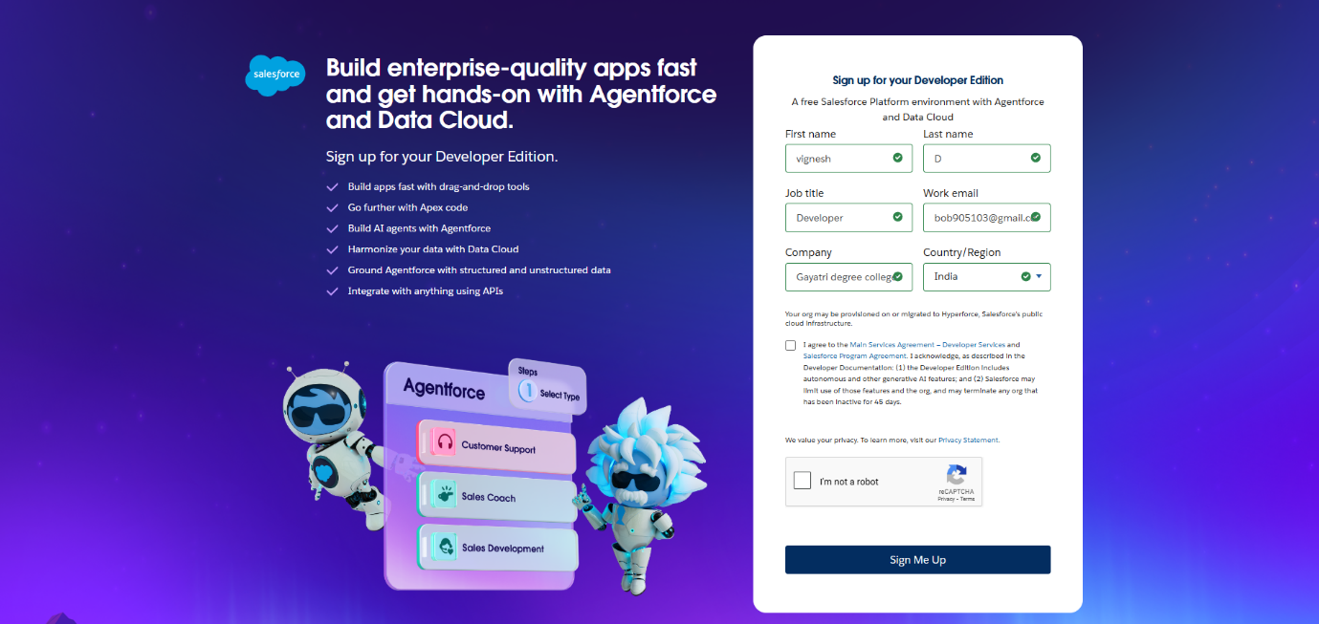

1. First name : VIGNESH

2. Last name : D

3. Email : bob905103@gmail.com

4. Role : Developer

5. Company : Gayatri degree college-Tirupati

6. County : India

7. Postal Code : 517501

8. Username : [bob905103598@agentforce.com](mailto:bob905103598@agentforce.com)

# Account Activation

1. Go to the inbox of the email that you used while signing up. Click on the verify

account to activate your account. The email may take 5-10mins.

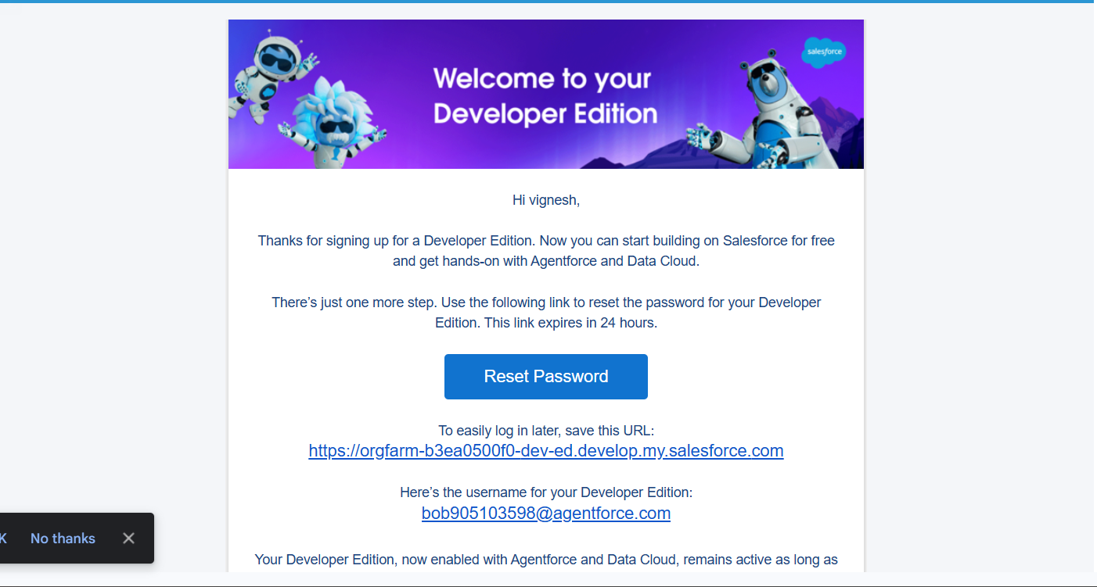

2. Click on Verify Account

3. Give a password and answer a security question and click on change password.

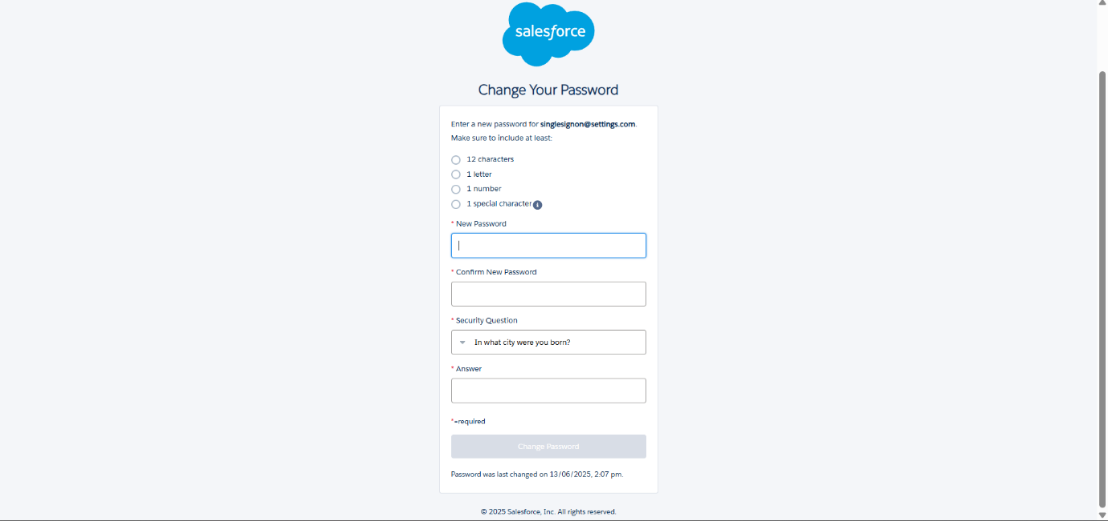

4.Then you will redirect to your salesforce setup page.

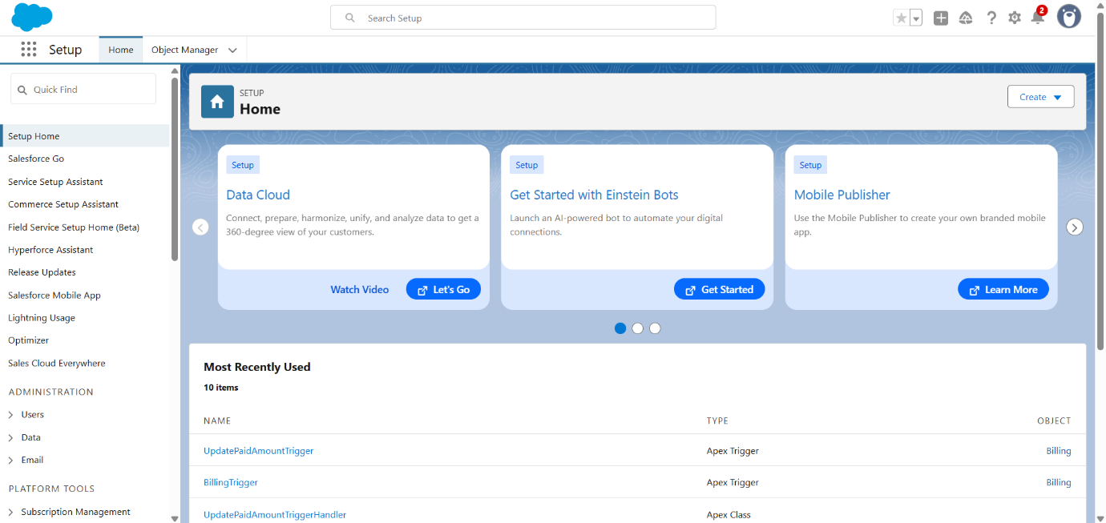

# MILESTONE-2

# Object

Create Jewel Customer Object

The purpose of creating a Jewel Customer custom object is to store and

manage information about Customer.

To create an object:

1. From the setup page >> Click on Object Manager >> Click on

Create >> Click on Custom Object.

2. Enter the label name >> Jewel Customer

3. Plural label name >> Jewel Customers

4. Enter Record Name Label and Format

• Record Name >> Customer name

• Data Type >> Text

5. Click on Allow reports.

6. Allow search >> Save.

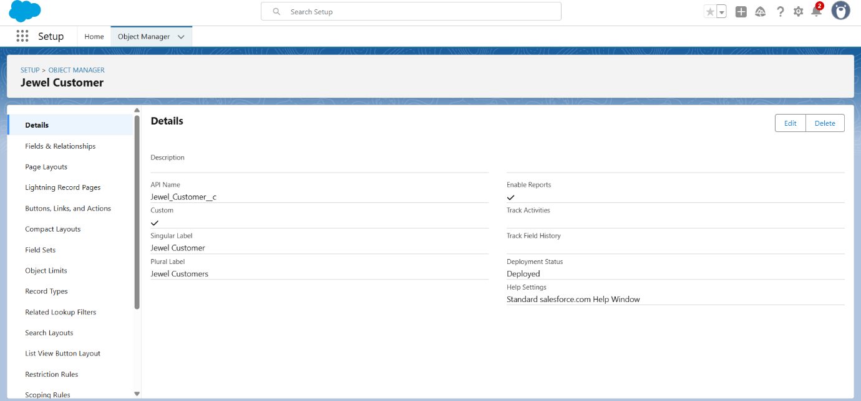

# Create Item Object

The purpose of creating a Item object is to manage the inventory of gold and

silver items.

To create an object:

1. From the setup page >> Click on Object Manager >> Click on

Create >> Click on Custom Object.

1. Enter the label name >> Item

2. Plural label name >> Items

3. Enter Record Name Label and Format

1. Record Name >> Item Id
2. Data Type >> Auto Number
3. Display Format >> Item-{00}
4. Starting Number >> 1

2. Click on Allow reports.

3. Allow search >> Save.

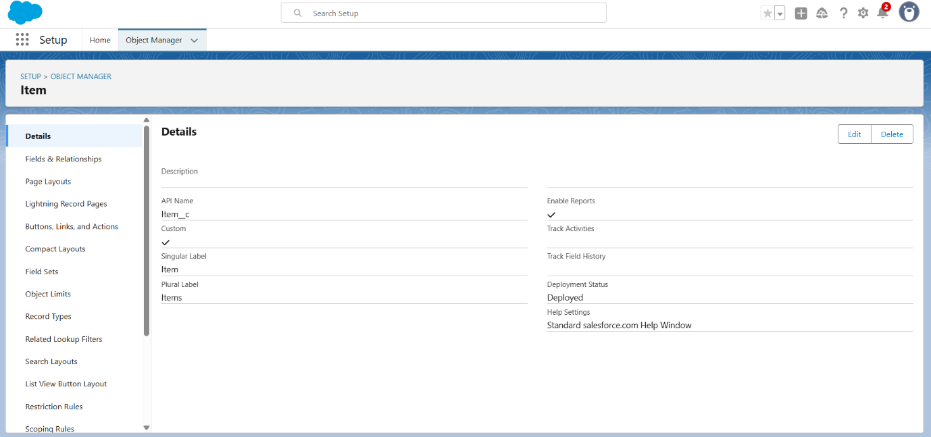

# Create Customer Order Object

The purpose of creating a Item object is to manage the inventory of gold and silver

items.

To create an object:

1. From the setup page >> Click on Object Manager >> Click on

Create >> Click on Custom Object.

1. Enter the label name >> Customer Order

2. Plural label name >> Customer Orders

3. Enter Record Name Label and Format

1. Record Name >> Customer Order No
2. Data Type >> Auto Number
3. Display Format >> Order - {0000}
4. Starting Number >> 1

4. Click on Allow reports.

5. Allow search >> Save.

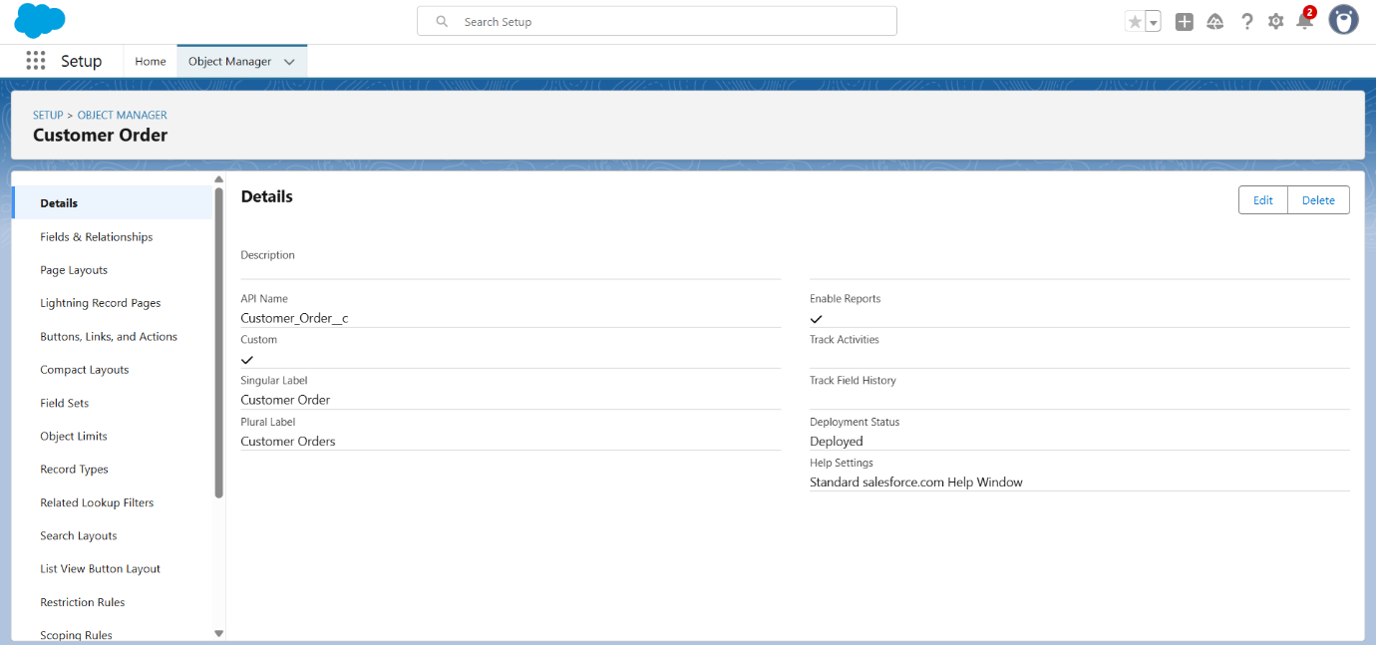

# Create Price Object

The purpose of creating a Item object is to manage the inventory of gold and silver

items.

To create an object:

1. From the setup page >> Click on Object Manager >> Click on

Create >> Click on Custom Object.

1. Enter the label name >> Price

2. Plural label name >> Prices

3. Enter Record Name Label and Format

1. Record Name >> Item Price
2. Data Type >> Text

4. Click on Allow reports.

5. Allow search >> Save.

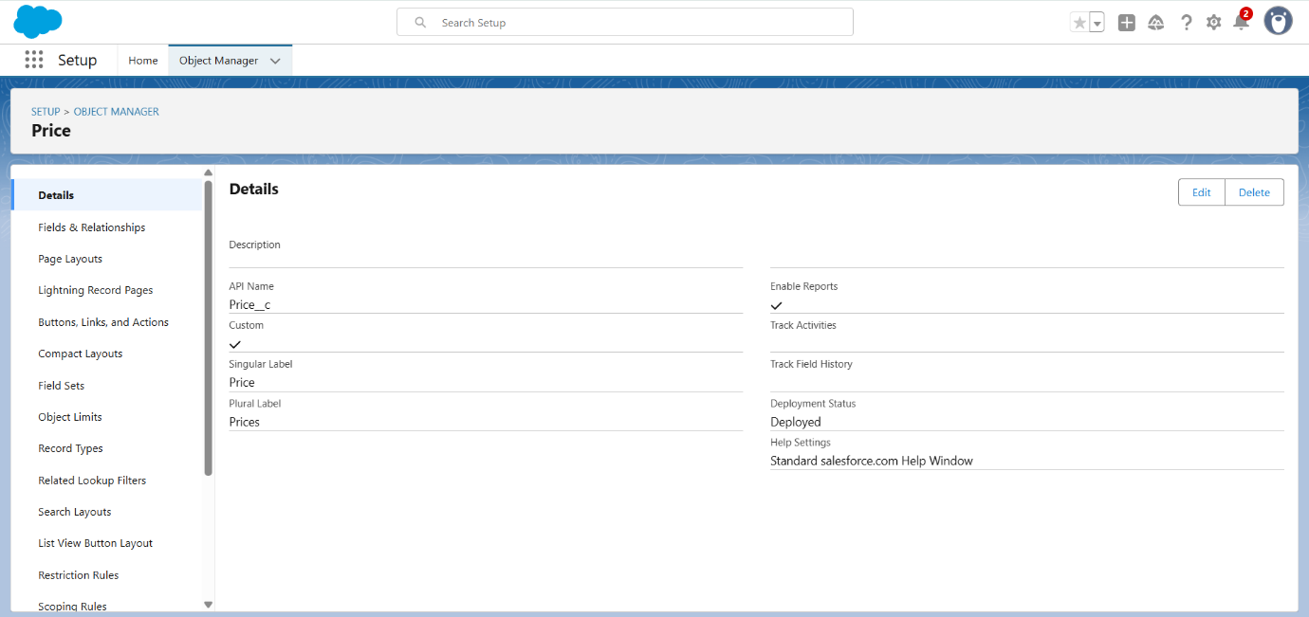

# Create Billing Object

The purpose of creating a Item object is to manage the inventory of gold and silver

items.

To create an object:

1. From the setup page >> Click on Object Manager >> Click on

Create >> Click on Custom Object.

1. Enter the label name >> Billing

2. Plural label name >> Billings

3. Enter Record Name Label and Format

1. Record Name >>Billing Name
2. Data Type >> Text

4. Click on Allow reports.

5. Allow search >> Save.

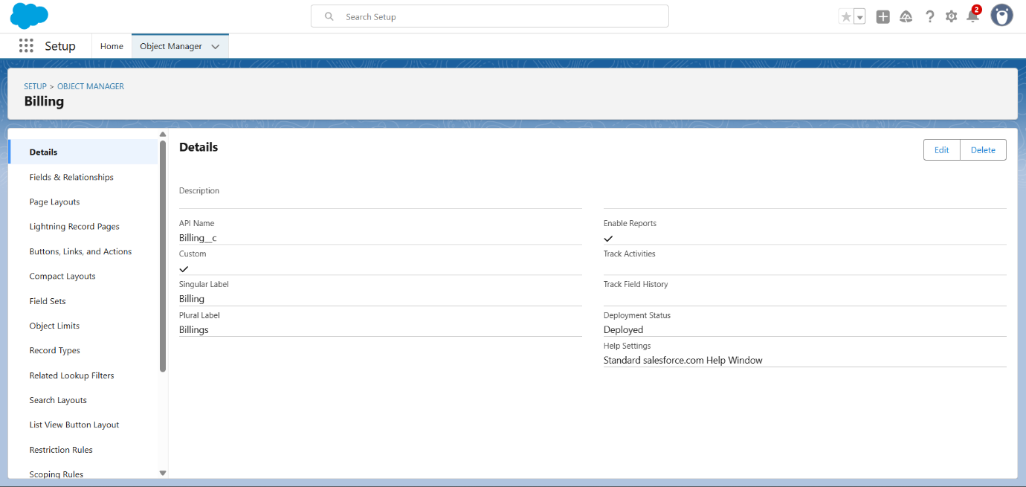

# MILESTONE-3

# Tabs

# Creating a Custom Tab

To create a Tab:(Customer)

1. Go to setup page >> type Tabs in Quick Find bar >> click on tabs >> New

(under custom object tab).

2. Select Object(Jewel Customer) >> Select any tab style >> Next (Add to

profiles page) keep it as default >> Next (Add to Custom App) keep it

as default >> Save.

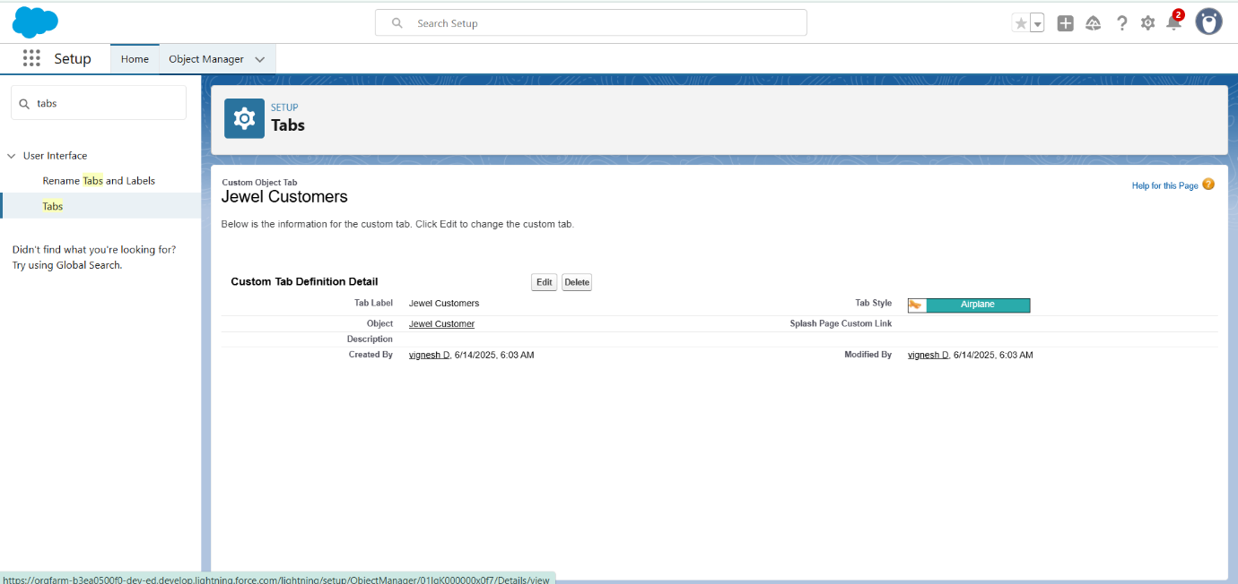

**Note**: Now create tabs for Customer Order, Price, Billing objects.

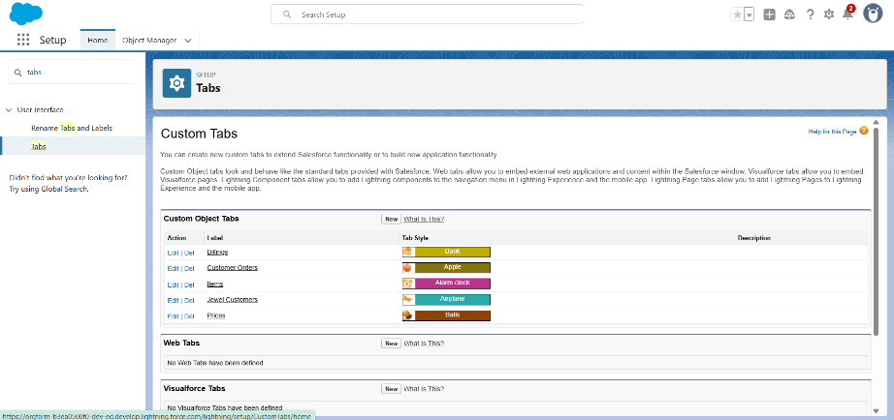

# MILESTONE-4

# The Lighting App

Create a Lightning App

To create a lightning app page:

1. Go to setup page >> search “app manager” in quick find >> select “app

manager” >> click on New lightning App.

2. Fill the app name in app details and branding as follow

App Name : Jewelry Inventory System.

Developer Name : This will auto populated

Description : Elevate your look with elegance

Image : optional (if you want to give any image you can otherwise not mandatory)

Primary colour hex value : keep this default.

3. Then click Next >> (App option page)Set Navigation Style as Console Navigation

>> Next.

4. (Utility Items) keep it as default >> Next.

5. To Add Navigation Items:Search for the item in the

(JewelCustomer,Item,CustomerOrder,Price,Billing,Reports,Dashboard) from the

search bar and move it using the arrow button >> Next >> Next.

6. To Add User Profiles:

Search profiles (System administrator) in the search bar >> click on the arrow button

>> save & finish.

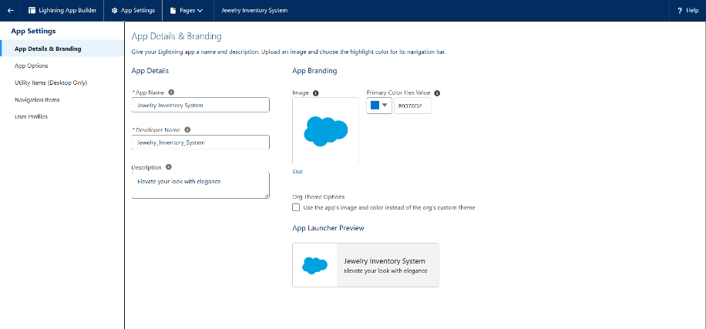

# MILESTONE-5

# Fields

Creating Lookup Relationship

To Create a relationship between Jewel Customer & Customer Order Objects.

1. Go to the setup page >> click on object manager >> type object name(Customer

Order) in the quick find bar >> click on the object.

2. Click on fields & relationship >> click on New.

3. Select “Lookup relationship” as data type and click Next.

4. Select the related object “ Jewel Customer ”.

5. Give Field Label as “Customer” and click Next.

6. Next >> Next >> Save.

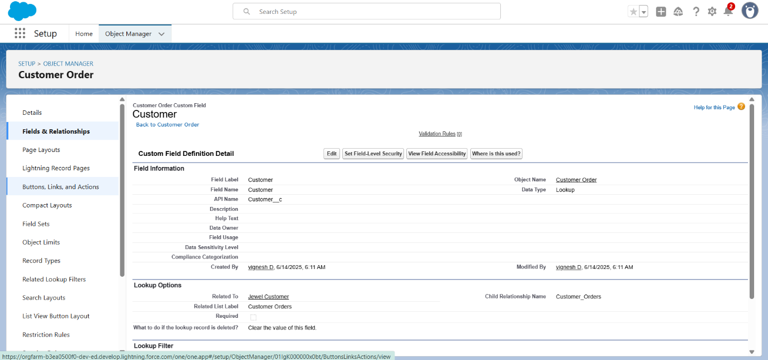

Creating Master-Detail Relationship between Item & Customer Order Object

**To Create a Master-Detail relationship :**

1. Go to the setup page >> click on object manager >> type object name(Customer

Order) in the quick find bar >> click on the object.

2. Click on fields & relationships >> click on New.

3. Select “Master-Detail relationship” as data type and click Next.

4. Select the related object “ Item”.

5. Give Field Label as “Item” and click Next.

6. Next >> Next >> Save.

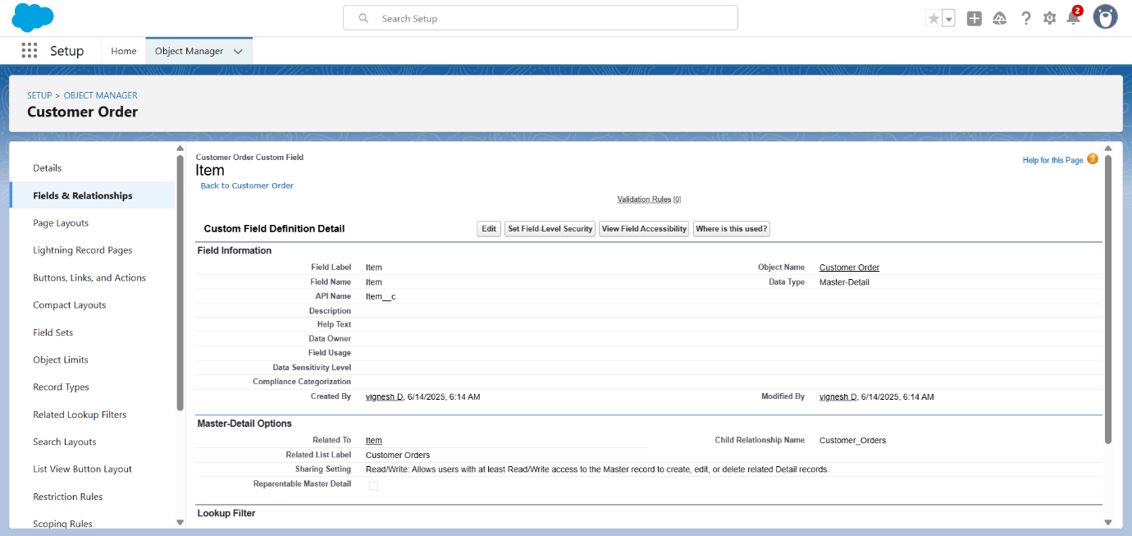

Creating Text Field in Jewel Customer Object

**To create fields in an object:**

1. Go to setup >> click on Object Manager >> type object name(Jewel Customer )

in quick find bar >> click on the object.

2. Now click on “Fields & Relationships” >> New

3. Select Data type as “Text”.

4. Click on Next

5. Fill the above as following:

o Field Label: City

o Length : 20

o Field Name : gets auto generated

o Click on Next >> Next >> Save and new.

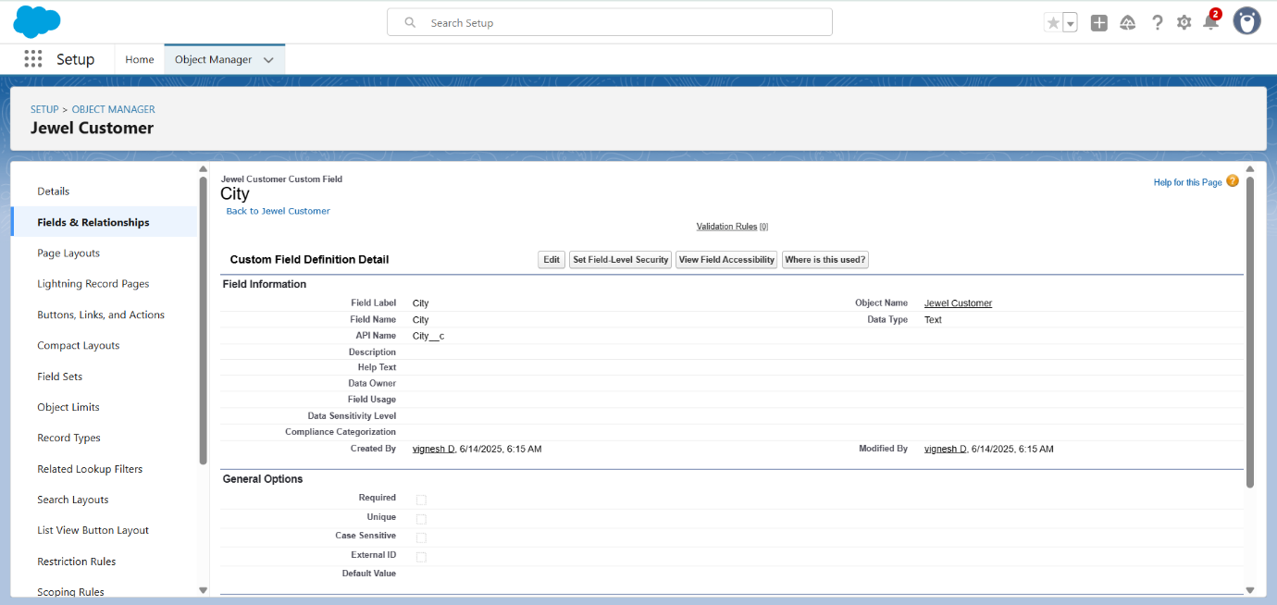

**Note**: Now create fields for Jewel Customer Phone(phone),Email(email).

Creating the number field in Item object

**To create fields in an object:**

1. Go to setup >> click on Object Manager >> type object name(Item) in quick find

bar >> click on the object.

2. Now click on “Fields & Relationships” >> New

3. Select Data type as “Number” and click Next.

4. Given the Field Label as “ Purity” and length as “ 2 ”.

5. Field Name will be auto populated, and click on Next >> Next >> Save.

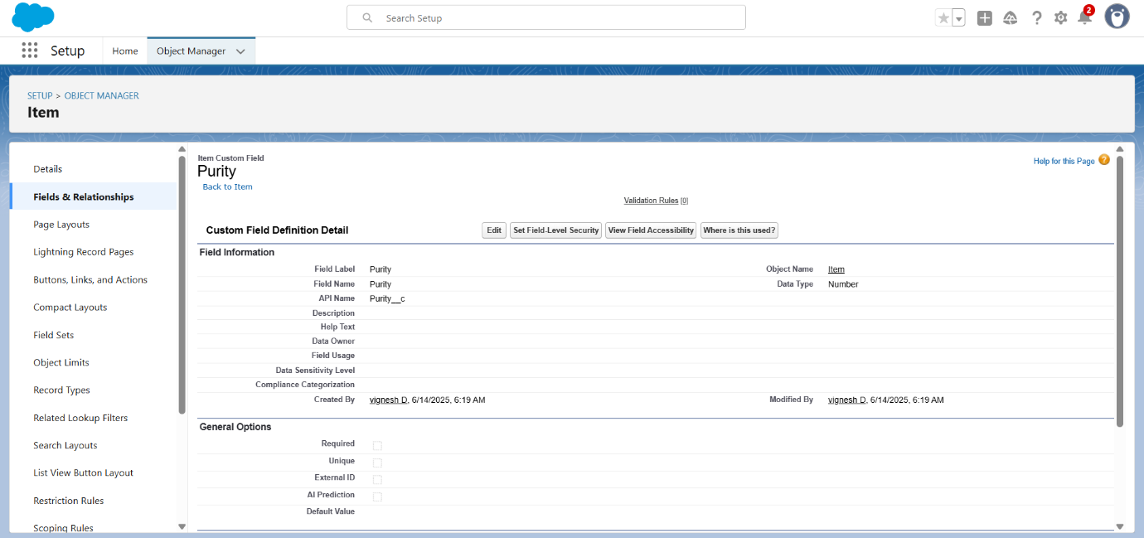

Creating Picklist Field in Item Object

**To create fields in an object:**

1. Go to setup >> click on Object Manager >>type object name(Item) in quick find

bar >> click on the object.

2. Now click on “Fields & Relationships” ? New.

3. Select Data type as “Picklist” and click Next.

4. Enter Field Label as “Item Type”.

5. In values select “Enter values(Gold,Silver), with each value separated by a new line"

and enter values as shown below.

6. Click Next >> Next >> Next >> Save .

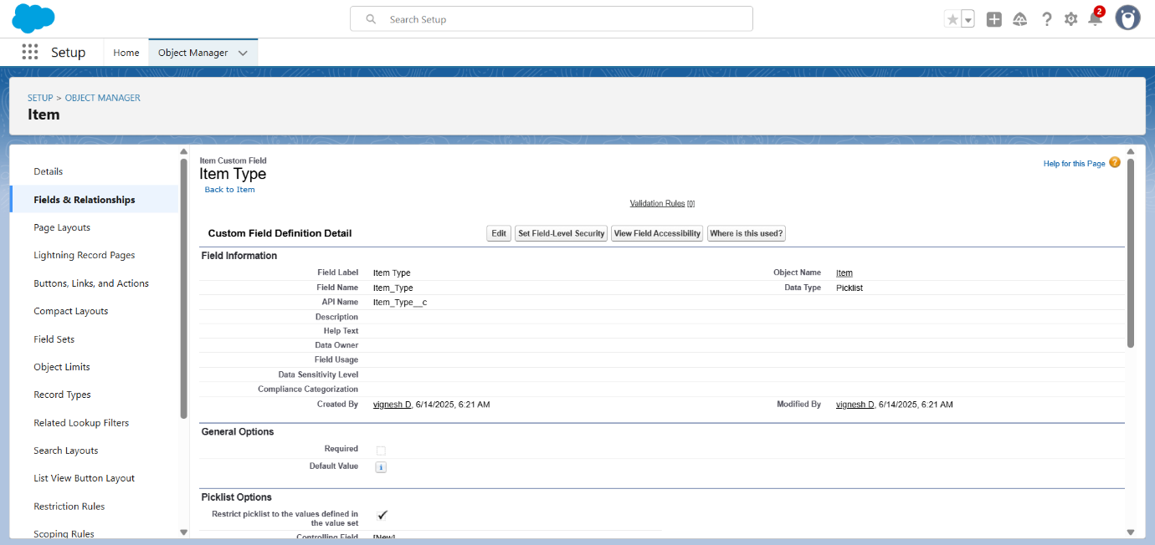

Creating Currency Field in Price Object

To create fields in an object:

1. Go to setup >> click on Object Manager >> type object name(Price) in quick

find bar >> click on the object.

2. Now click on “Fields & Relationships” >> New.

3. Select Data type as “Currency” and click Next.

4. Enter Field Label as “Gold Price” and length as “ 8”and decimal 5.Field name will

be auto generated.

5. Click Next >> Next >> Next >> Save .

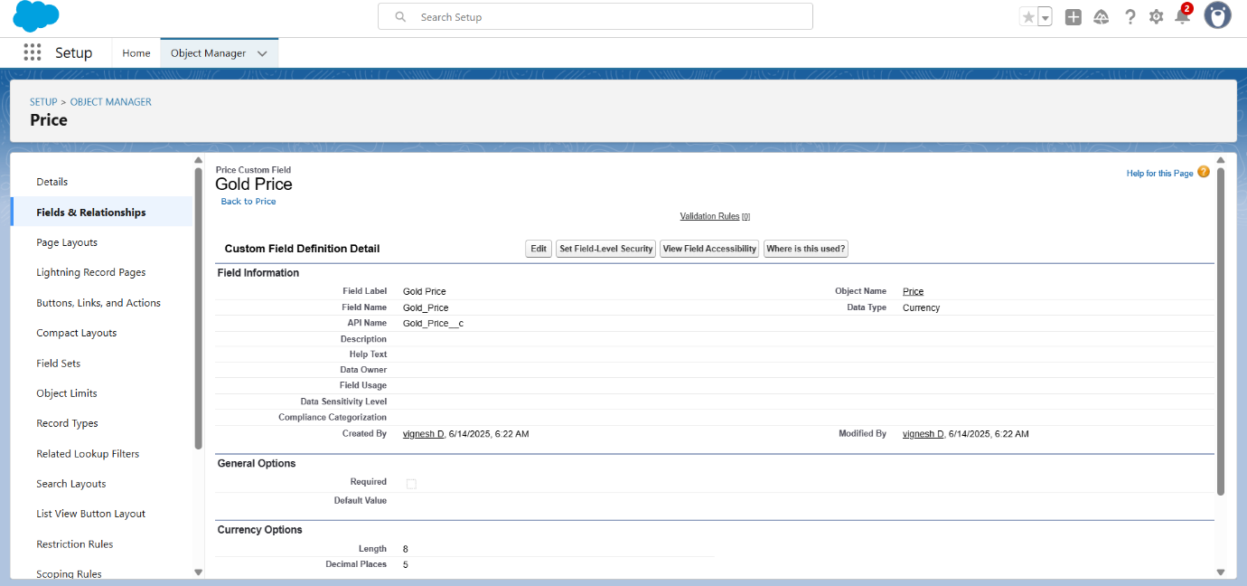

Creating Formula Field(Cross Object) in Item Object

**To create fields in an object:**

(Note: Create a Lookup Relationship in Item Object to Price Object with Field Name:

Prices)

1. Go to setup >> click on Object Manager >> type object name (Item) in quick

find bar >> click on the object.

2. Now click on “Fields & Relationships” >> New.

3. Select Data type as “Formula” and click Next.

4. Give Field Label and Field Name as “Gold Price” and select formula return type

as “Currency” and click next.

5. Under Advanced Formula write down the formula : Prices__r.Gold_price__c /10.

6. Click “Check Syntax” and Next >> Next >> Save & New.

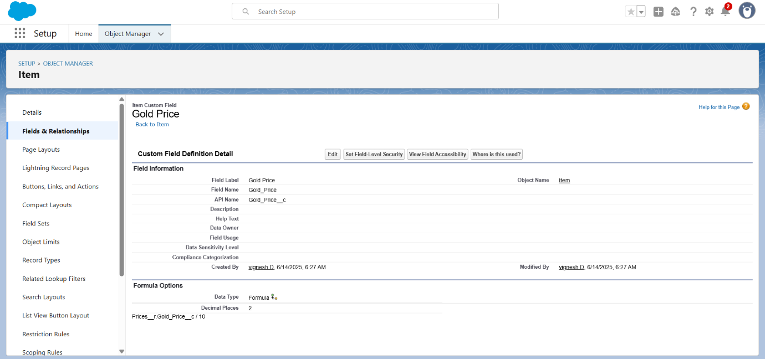

Creating Text Field in Jewel Customer Object

**To create fields in an object:**

1. Go to setup >> click on Object Manager >> type object name(Jewel Customer )

in quick find bar >> click on the object.

2. Now click on “Fields & Relationships” >> New

3. Select Data type as “Text”.

4. Click on Next

5. Fill the above as following:

o Field Label: State

o Length : 20

o Field Name : gets auto generated

o Click on Next >> Next >> Save and new.

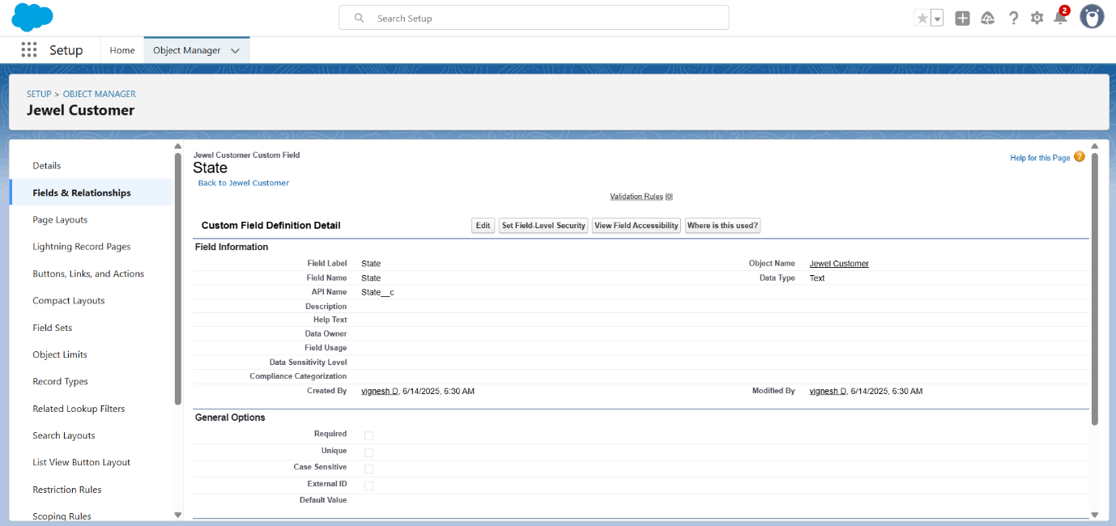

**Note:** create some text fields in jewel customer as:

Now click on “Fields & Relationships” >> New

Select Data type as “Text”.

Click on Next

Fill the above as following:

o Field Label: Street

o Lengt h : 20

o Field Name : gets auto generated

o Click on Next >> Next >> Save and new.

**Creating Text Field in Jewel Customer Object**

Select Data type as “Text”.

Click on Next

Fill the above as following:

o Field Label: Country

o Length : 18

o Field Name : gets auto generated

o Click on Next >> Next >> Save and new.

**Creating Text Field in Jewel Customer Object**

Select Data type as “Text”.

Click on Next

Fill the above as following:

o Field Label: Zip/Postal code

o Length : 6

o Field Name : gets auto generated

o Click on Next >> Next >> Save

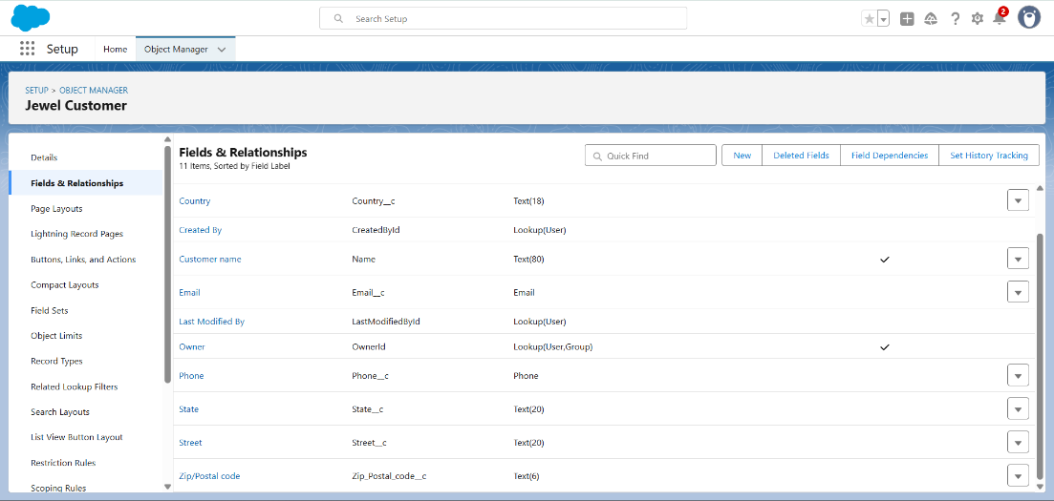

Creating Currency Field in Price Object

**To create fields in an object:**

1. Go to setup >> click on Object Manager >> type object name (Price) in quick

find bar >> click on the object.

2. Now click on “Fields & Relationships” >> New.

3. Select Data type as “Currency” and click Next.

4. Enter Field Label as “ Silver Price” and length as “ 8”and decimal 5.Field name

will be auto generated.

5. Click Next >> Next >> Next >> Save .

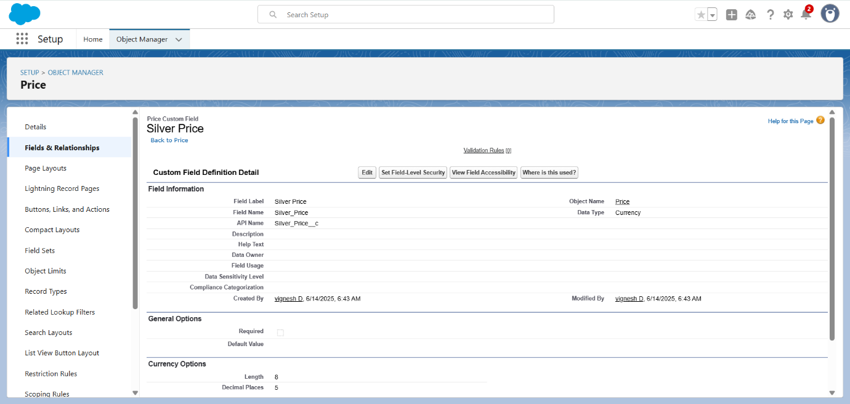

Creating Lookup Relationship

1. Go to the setup page >> click on object manager >> type object name (Item) in the

quick find bar >> click on the object

2. Click on fields & relationship >> click on New.

3. Select “Lookup relationship” as data type and click Next.

4. Select the related object “ Jewel Customer ”.

5. Give Field Label as “Customer Name” and click Next.

6. Next >> Next >> Save.

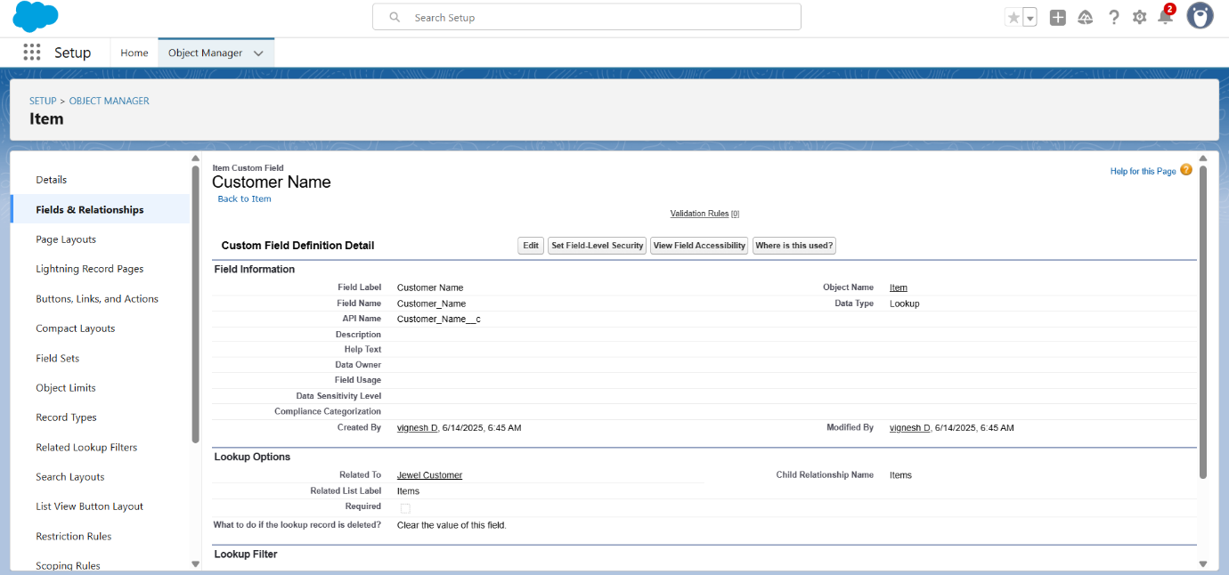

**Note:** create some text fields in item object as:

**Creating Text Field in Item Object**

**To create fields in an object:**

1. Go to setup >> click on Object Manager >> type object name (Item) in quick find

bar >> click on the object.

2. Now click on “Fields & Relationships” >> New

3. Select Data type as “Text”.

4. Click on Next

5. Fill the above as following:

o Field Label: Ornament

o Length : 20

o Field Name : gets auto generated

o Click on Next >> Next >> Save and new.

**Creating the number field in Item object**

**To create fields in an object:**

1. Go to setup >> click on Object Manager >> type object name (Item) in quick find

bar >> click on the object.

2. Now click on “Fields & Relationships” >> New

3. Select Data type as “Number” and click Next.

4. Given the Field Label as “ Weight ” and length as “ 8 ” , Decimal as “5”.

5. Field Name will be auto populated, and click on Next >> Next >> Save.

**Creating the number field in Item object**

**To create fields in an object:**

1. Go to setup >> click on Object Manager >> type object name (Item) in quick find

bar >> click on the object.

2. Now click on “Fields & Relationships” >> New

3. Select Data type as “Number” and click Next.

4. Given the Field Label as “ Stone Weight ” and length as “ 5 ” , Decimal as “5”.

5. Field Name will be auto populated, and click on Next >> Next >> Save.

**Creating the number field in Item object**

**To create fields in an object:**

1. Go to setup >> click on Object Manager >> type object name (Item) in quick find

bar >> click on the object.

2. Now click on “Fields & Relationships” >> New

3. Select Data type as “Number” and click Next.

4. Given the Field Label as “ Percentage” and length as “ 2 ” , Decimal as “ 0 ”.

5. Field Name will be auto populated, and click on Next >> Next >> Save.

**Creating the number field in Item object**

**To create fields in an object:**

1. Go to setup >> click on Object Manager >> type object name (Item) in quick find

bar >> click on the object.

2. Now click on “Fields & Relationships” >> New

3. Select Data type as “Currency” and click Next.

4. Given the Field Label as “ Stone/Other Price” and length as “ 8 ” , Decimal as “ 2 ”.

5. Field Name will be auto populated, and click on Next >> Next >> Save.

**Creating Picklist Field in Item Object**

**To create fields in an object:**

1. Go to setup >> click on Object Manager >>type object name (Item) in quick find

bar >> click on the object.

2. Now click on “Fields & Relationships” ? New.

3. Select Data type as “Picklist” and click Next.

4. Enter Field Label as “Expected Days Of Return”.

5. In values select “Enter values (1-3 Days, 4-5 Days,6-7 Days 8-10 Days), with each

value separated by a new line" and enter values as shown below.

6. Click Next >> Next >> Next >> Save .

**Creating Picklist Field in Item Object**

**To create fields in an object:**

1. Go to setup >> click on Object Manager >>type object name (Item) in quick find

bar >> click on the object.

2. Now click on “Fields & Relationships” ? New.

3. Select Data type as “Picklist” and click Next.

4. Enter Field Label as “Priority”.

5. In values select “Enter values (Low, Medium, High, Critical), with each value

separated by a new line" and enter values as shown below.

6. Click Next >> Next >> Next >> Save .

**Creating Formula Field in Item Object**

**To create fields in an object:**

1. Go to setup >> click on Object Manager >> type object name (Item) in quick find

bar >> click on the object.

2. Now click on “Fields & Relationships” >> New.

3. Select Data type as “Formula” and click Next.

4. Give Field Label and Field Name as “Silver Price” and select formula return type as

“Number” and Decimal as ” 3 ” and click next.

5. Under Advanced Formula write down the formula : (Prices__r.Silver_price__c /

1000).

6. Click “Check Syntax” and Next >> Next >> Save & New.

**Creating Formula Field in Item Object**

1. Go to setup >> click on Object Manager >> type object name (Item) in quick find

bar >> click on the object.

2. Now click on “Fields & Relationships” >> New.

3. Select Data type as “Formula” and click Next.

4. Give Field Label and Field Name as “Purity Gold Price” and select formula return

type as “Currency” and Decimal as ” 2 ” and click next.

5. Under Advanced Formula write down the formula : ((Prices__r.Gold_price__c

* Purity__c ) / 24) / 10

6. click “Check Syntax” and Next >> Next >> Save & New.

**Creating Formula Field in Item Object**

1. Go to setup >> click on Object Manager >> type object name (Item) in quick find

bar >> click on the object.

2. Now click on “Fields & Relationships” >> New.

3. Select Data type as “Formula” and click Next.

4. Give Field Label and Field Name as “Total Weight” and select formula return type as

“Number” and Decimal as ” 3 ” and click next.

5. Under Advanced Formula write down the formula : (Weight__c - Stone_weight__c)

6. click “Check Syntax” and Next >> Next >> Save & New.

**Creating Formula Field in Item Object**

1. Go to setup >> click on Object Manager >> type object name (Item) in quick find

bar >> click on the object.

2. Now click on “Fields & Relationships” >> New.

3. Select Data type as “Formula” and click Next.

4. Give Field Label and Field Name as “Amount” and select formula return type as

“Currency” and Decimal as ” 3 ” and click next.

5. Under Advanced Formula write down the formula : IF(ISPICKVAL( Item_Type__c

,"Gold"), Total_weight__c * Purity_Gold_price__c , Total_weight__c * Silver_price__c )

6. click “Check Syntax” and Next >> Next >> Save & New.

**Creating Formula Field in Item Object**

1. Go to setup >> click on Object Manager >> type object name (Item) in quick find

bar >> click on the object.

2. Now click on “Fields & Relationships” >> New.

3. Select Data type as “Formula” and click Next.

4. Give Field Label and Field Name as “KDM” and select formula return type as

“Currency” and Decimal as ” 0 ” and click next.

5. Under Advanced Formula write down the formula :

(Amount__c * Percentage__c ) / 100

6. Click “Check Syntax” and Next >> Next >> Save & New.

**Creating Formula Field in Item Object**

1. Go to setup >> click on Object Manager >> type object name (Item) in quick find

bar >> click on the object.

2. Now click on “Fields & Relationships” >> New.

3. Select Data type as “Formula” and click Next.

4. Give Field Label and Field Name as “Making Charges” and select formula return type

as “Currency” and Decimal as ” 0 ” and click next.

5. Under Advanced Formula write down the formula : IF(ISPICKVAL( Item_Type__c

,"Gold"), Weight__c * 300 , Weight__c * 10 )

6. Click “Check Syntax” and Next >> Next >> Save & New.

**The fields are created as shown in the below image:**

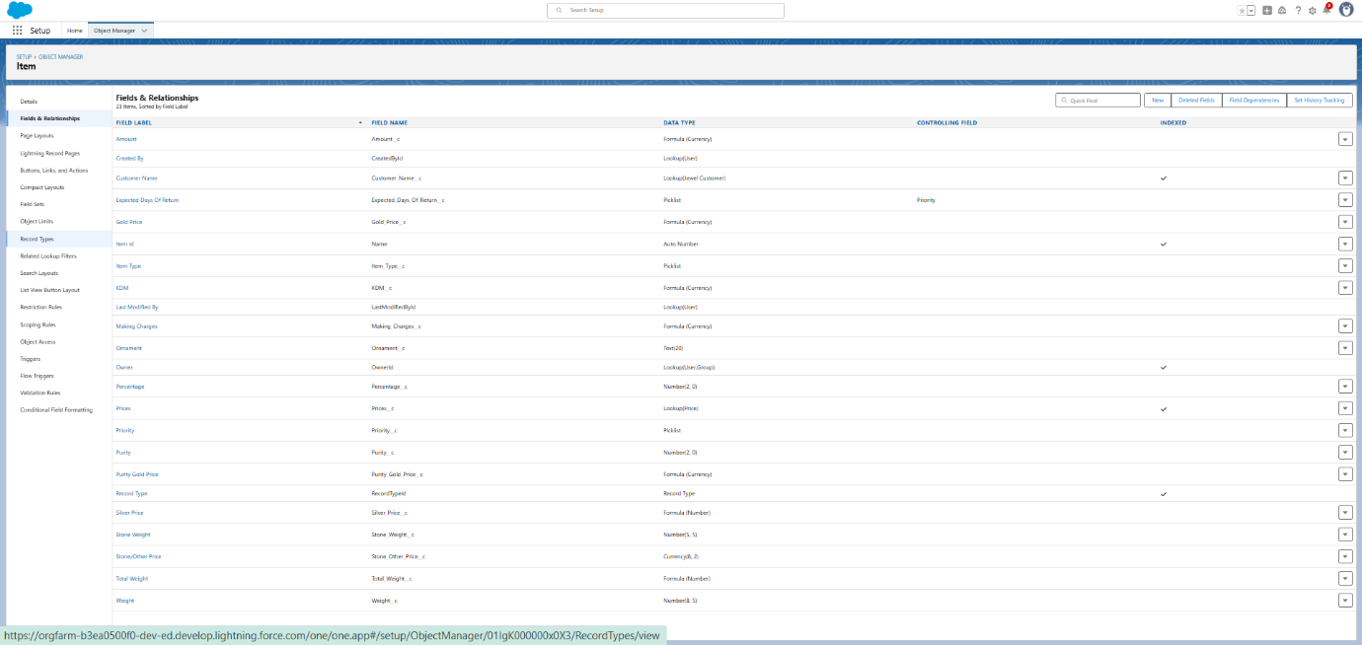

Creating Picklist Field in Customer Order Object

**To create fields in an object:**

1. Go to setup >> click on Object Manager >>type object name (**Customer Order**) in quick findbar >> click on the object.

2. Now click on “Fields & Relationships” ? New.

3. Select Data type as “Picklist” and click Next.

4. Enter Field Label as “Order Status”.

5. In values select “Enter values(Started, NotStarted, OnHold, Completed, Not

Completed), with each value separated by a new line" and enter values as shown below.

6. Click Next >> Next >> Next >> Save

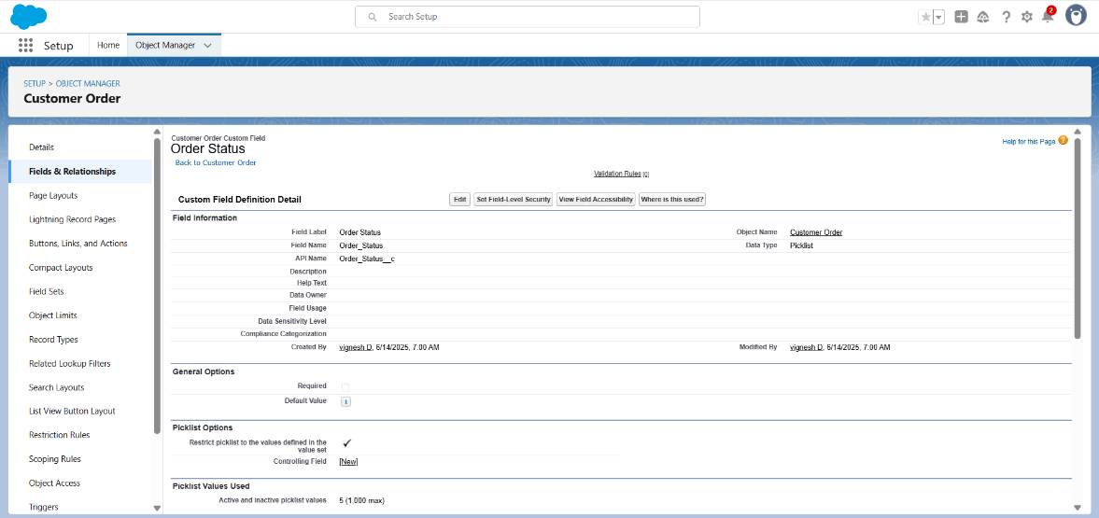

Creating Lookup Relationship

1. Go to the setup page >> click on object manager >> type object name (Billing) in

the quick find bar >> click on the object

2. Click on fields & relationship >> click on New.

3. Select “Lookup relationship” as data type and click Next.

4. Select the related object “Item”.

5. Give Field Label as “Item” and click Next.

6. Next >> Next >> Save.

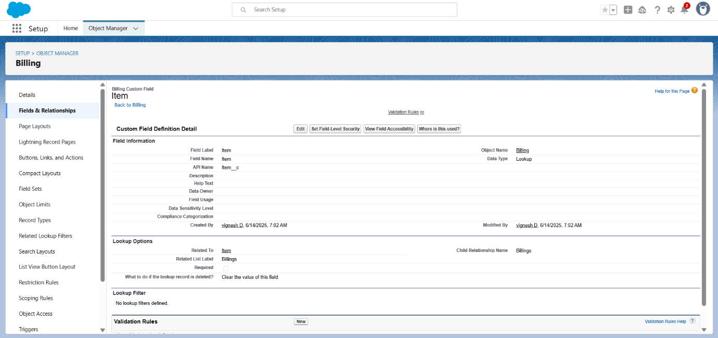

**Note:** create some fields in the billing object as:

**Creating Formula Field in Billing Object**

1. Go to setup >> click on Object Manager >> type object name (Billing) in quick

find bar >> click on the object.

2. Now click on “Fields & Relationships” >> New.

3. Select Data type as “Formula” and click Next.

4. Give Field Label and Field Name as “Ornament” and select formula return type as

“Text” and click next.

5. Under Advanced Formula write down the formula : Item__r.Ornament__c

6. Click “Check Syntax” and Next >> Next >> Save & New.

**Creating Formula Field in Billing Object**

1. Go to setup >> click on Object Manager >> type object name (Billing) in quick find

bar >> click on the object.

2. Now click on “Fields & Relationships” >> New.

3. Select Data type as “Formula” and click Next.

4. Give Field Label and Field Name as “Stone weight” and select formula return type

as “Number” and Decimal as ” 2 ” and click next.

5. Under Advanced Formula write down the formula : Item__r.Stone_weight__c

6. Click “Check Syntax” and Next >> Next >> Save & New.

**Creating Formula Field in Billing Object**

1. Go to setup >> click on Object Manager >> type object name (Billing) in quick find

bar >> click on the object.

2. Now click on “Fields & Relationships” >> New.

3. Select Data type as “Formula” and click Next.

4. Give Field Label and Field Name as “Weight” and select formula return type as

“Number” and Decimal as ” 2 ” and click next.

5. Under Advanced Formula write down the formula : Item__r.Total_weight__c

6. click “Check Syntax” and Next >> Next >> Save & New.

**Creating Formula Field in Billing Object**

1. Go to setup >> click on Object Manager >> type object name (Billing) in quick find

bar >> click on the object.

2. Now click on “Fields & Relationships” >> New.

3. Select Data type as “Formula” and click Next.

4. Give Field Label and Field Name as “Amount” and select formula return type as

“Currency” and Decimal as ” 2 ” and click next.

5. Under Advanced Formula write down the formula : Item__r.Amount__c

6. click “Check Syntax” and Next >> Next >> Save & New.

**Creating Formula Field in Billing Object**

1. Go to setup >> click on Object Manager >> type object name (Billing) in quick find

bar >> click on the object.

2. Now click on “Fields & Relationships” >> New.

3. Select Data type as “Formula” and click Next.

4. Give Field Label and Field Name as “Gold/Silver Price” and select formula return

type as “Currency” and Decimal as ” 2 ” and click next.

5. Under Advanced Formula write down the formula :

IF(ISPICKVAL( Item__r.Item_Type__c ,"Gold"), Item__r.Gold_price__c , Item__r.Silver_

price__c )

6. click “Check Syntax” and Next >> Next >> Save & New.

**Creating Formula Field in Billing Object**

1. Go to setup >> click on Object Manager >> type object name (Billing) in quick find

bar >> click on the object.

2. Now click on “Fields & Relationships” >> New.

3. Select Data type as “Formula” and click Next.

4. Give Field Label and Field Name as “KDM Charge” and select formula return type as

“Currency” and Decimal as ” 0 ” and click next.

5. Under Advanced Formula write down the formula : Item__r.KDM__c

6. Click “Check Syntax” and Next >> Next >> Save & New.

**Creating Formula Field in Billing Object**

1. Go to setup >> click on Object Manager >> type object name (Billing) in quick find

bar >> click on the object.

2. Now click on “Fields & Relationships” >> New.

3. Select Data type as “Formula” and click Next.

4. Give Field Label and Field Name as “Making Charges” and select formula return type

as “Currency” and Decimal as ” 2 ” and click next.

5. Under Advanced Formula write down the formula : Item__r.Making_Charges__c

6. Click “Check Syntax” and Next >> Next >> Save & New.

**Creating Formula Field in Billing Object**

1. Go to setup >> click on Object Manager >> type object name (Billing) in quick find

bar >> click on the object.

2. Now click on “Fields & Relationships” >> New.

3. Select Data type as “Formula” and click Next.

4. Give Field Label and Field Name as “Stones/other price” and select formula return

type as “Currency” and Decimal as ” 2 ” and click next.

5. Under Advanced Formula write down the formula : Item__r.Stone_other_price__c

6. click “Check Syntax” and Next >> Next >> Save & New.

**Creating Formula Field in Billing Object**

1. Go to setup >> click on Object Manager >> type object name (Billing) in quick find

bar >> click on the object.

2. Now click on “Fields & Relationships” >> New.

3. Select Data type as “Formula” and click Next.

4. Give Field Label and Field Name as “Total Amount” and select formula return type

as “Currency” and Decimal as ” 0 ” and click next

5. Under Advanced Formula write down the formula : Amount__c +

KDM_Charge__c + Stones_other_price__c + Making_Charges__c

6. click “Check Syntax” and Next >> Next >> Save & New.

**The fields are created as shown in the below image:**

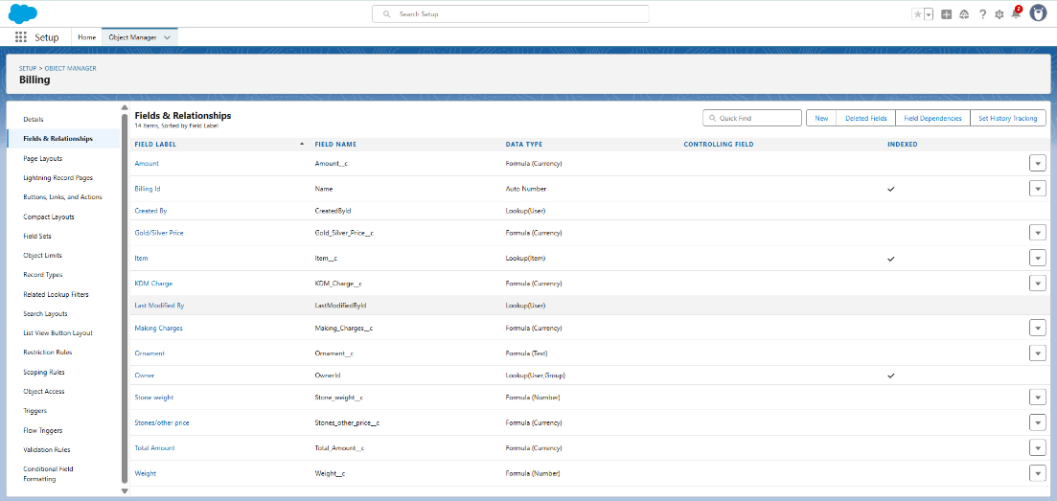

Schema Builder

Schema Builder is a powerful tool within Salesforce that allows you to visualise,

explore, and design the relationships between objects in your Salesforce

organisation. It provides a graphical representation of the data model, making it

easier to understand the structure and connections between different objects.

Creating Schema Builder

1. Go to setup >> click on Object Manager >> Schema Builder.

2. Select objects >> Enter Objects as “Jewel Customer,Item,Customer Order, Price,

Billing objects” in quick box and select them.

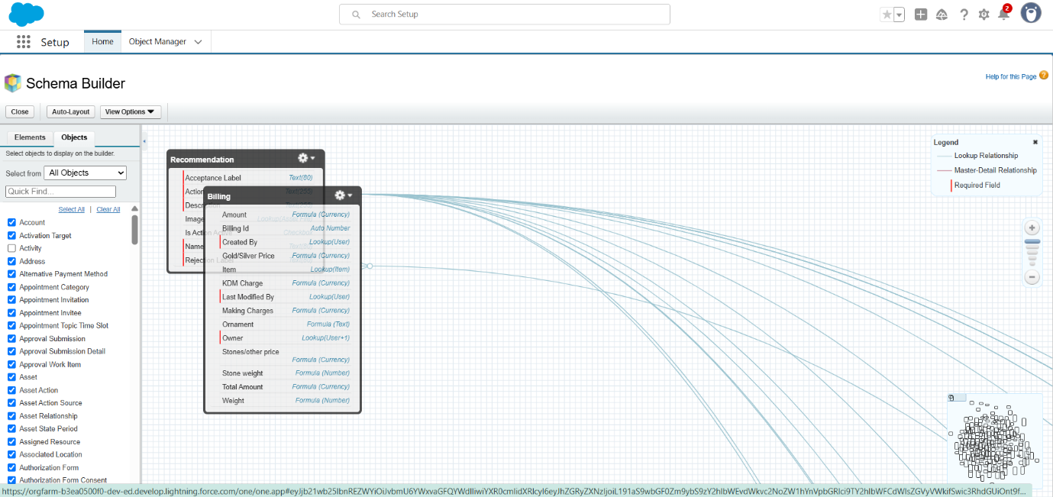

Creating the Field Dependencies

**Use case:**

Field Dependencies are used to create relationships between fields within an object.

They allow you to control the visibility and availability of fields based on the values

selected in other fields.

1. Go to setup >> click on Object Manager >> type object name(Item) in quick find

bar >>click on the object.

2. Click on Fields & Relationships and click on the Priority field.

3. Search for Field Dependencies and click on New.

4. Select Controlling Field as “Priority” and Depending field as “Expected Days of

Return”? Continue.

5. Select the “Expected Days of Return” values of related Priority values and Click

on Include Values >> Save.

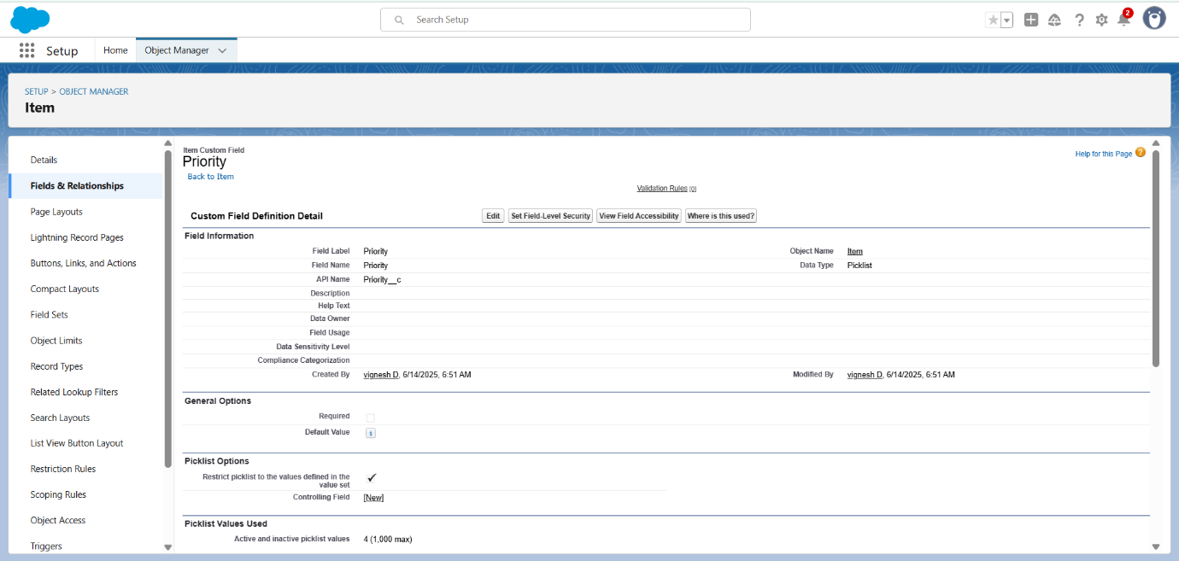

Creating the validation rule :

Creating the validation rule for Postal Code field in Jewel Customer object

**Note :** check whether the fields mentioned in the formula field are created or not , if

not go to activity 10 and create those fields mentioned in Jewel Customer object.

1. Go to setup >> click on Object Manager >> type object name (Jewel Customer ) in

quick find bar >> click on the object.

2. Click on the validation rule >> click New.

3. Enter the Rule name as “Postal Code “.

4. Insert the Error Condition Formula as : -

*AND(*

*OR(*

*LEN( Zip_Postal_code__c ) <> 6,*

*NOT(REGEX(Zip_Postal_code__c, "^[0-9]{6}$"))*

*),*

*NOT(ISBLANK(Zip_Postal_code__c))*

*)*

5. Enter the Error Message as “Must contain 6 digits”, select the Error location as Field

and select the field as “Zip/Postal code”, and click Save.

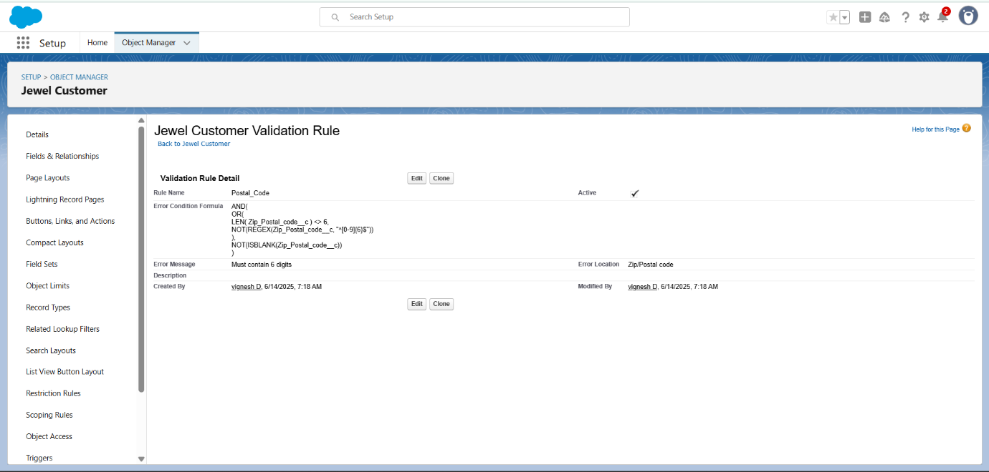

**NOTE:Create One more Validation rule for Jewel Customer object.**

1. Enter Rule name as “ValidationRule For JewelCustomerObject “.

2. Insert the Error Condition Formula as : -

*OR( ISBLANK( City__c ) , ISBLANK( Country__c ),ISBLANK( Phone__c*

*),ISBLANK( State__c ),ISBLANK( Street__c )*

3. Enter the Error Message as “Please fill Required fields”, select the Error location as

Top of Page and click Save.

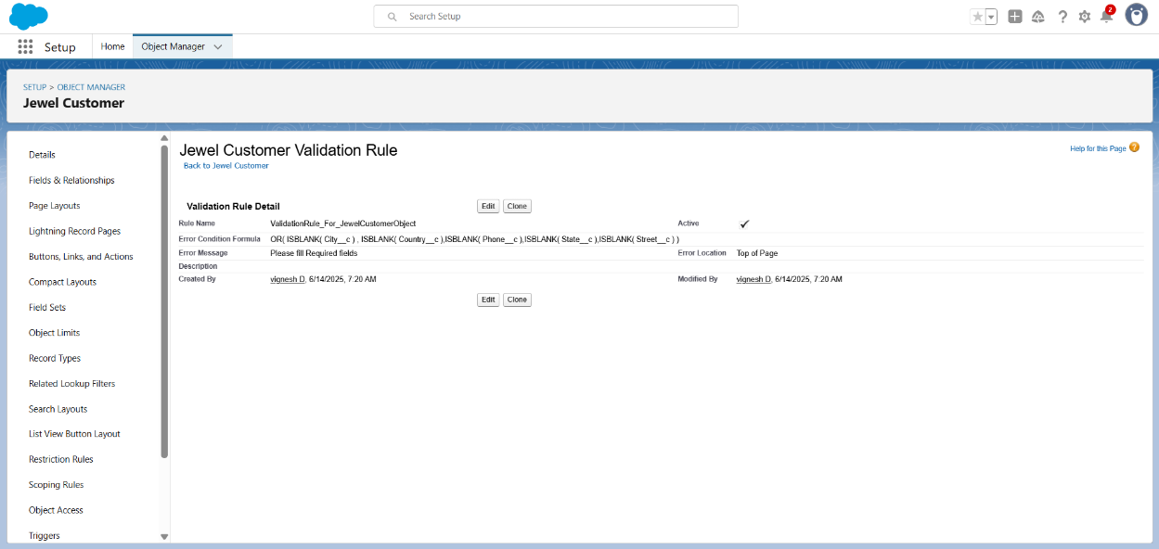

Create Validation rule for Item object.

1. Enter Rule name as “ValidationRule For Item“.

2. Insert the Error Condition Formula as : -

*OR( ISBLANK( Amount__c ) ,*

*ISBLANK( Customer_Name__c ) ,ISBLANK(*

*Gold_price__c ),ISBLANK( KDM__c ),ISBLANK(*

*Ornament__c ),ISBLANK( Percentage__c*

*),ISBLANK( Making_Charges__c ),ISBLANK(*

*Prices__c ),ISBLANK( Stone_weight__c*

*),ISBLANK( Silver_price__c ),ISBLANK(*

*Stone_other_price__c ),ISBLANK(*

*Stone_weight__c ),ISBLANK( Weight__c ))*

3. Enter the Error Message as “Please fill Required fields”, select the Error location

as Top of Page and click Save.

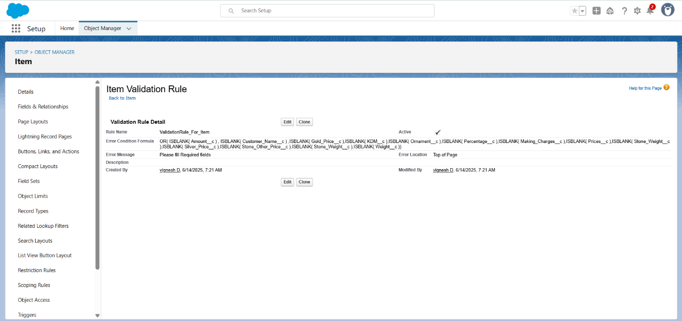

# MILESTONE-6

# Profiles

Gold Smith Profile

To create a new profile:

1. Go to setup >> type profiles in quick find box >> click on profiles >> clone the

desired profile (System Administrator) >> enter profile name (Gold Smith) >>

Save.

2. While still on the profile page, then click Edit.

3. Scroll down to Custom Object Permissions and Give access permissions for

Jewel Customer, Item, Customer Order, Prices, Billings .

4. Scroll down and Click on Save.

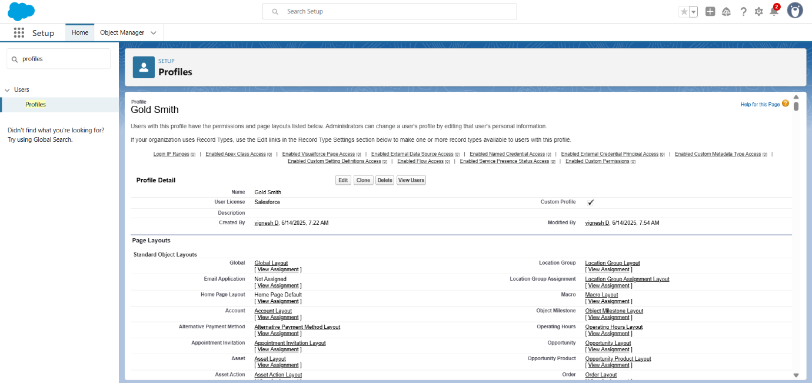

Worker Profile

1. Go to setup >> type profiles in quick find box >> click on profiles >> clone the

desired profile (Salesforce Platform User) >> enter profile name (Worker) >> Save.

2. While still on the profile page, then click Edit.

3. Scroll down to Custom Object Permissions and Give access permissions for Items,

Price and Customer Order objects.

4. Scroll down and Click on Save.

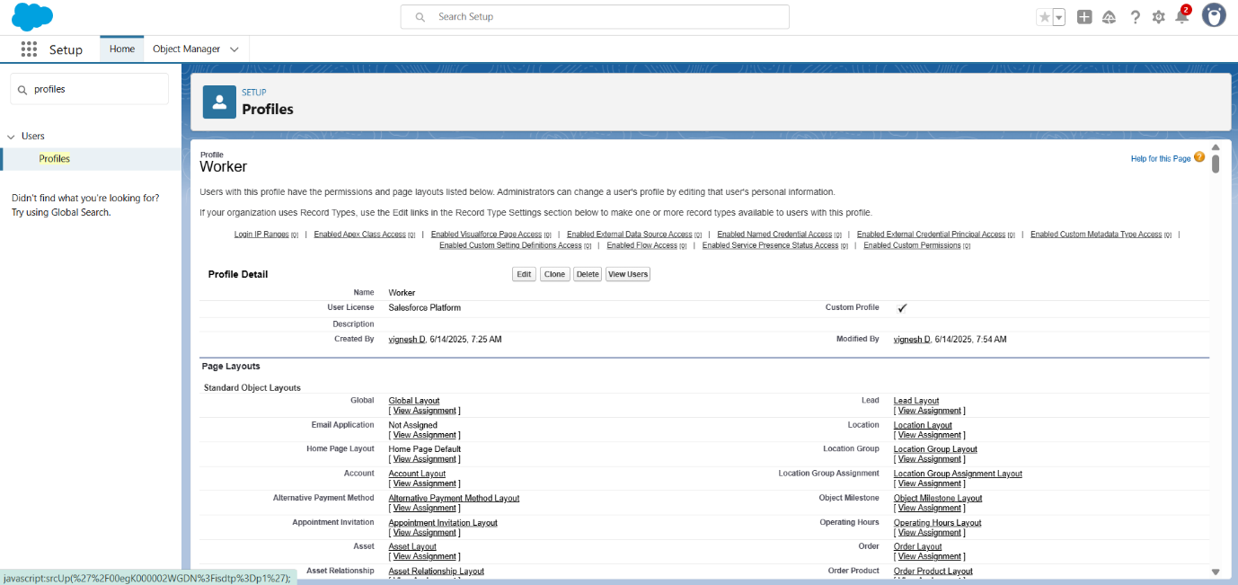

# MILESTONE-7

# Roles

Creating Gold Smith Role

1. From setup >> Go to quick find >> Search for Roles >> click on set up roles.

2. Click on Expand All and click on add role under whom this role works.

3. Give Label as “Gold Smith” and Role name gets auto populated. Check to

whom this role (Gold Smith) reports. Then click on Save.

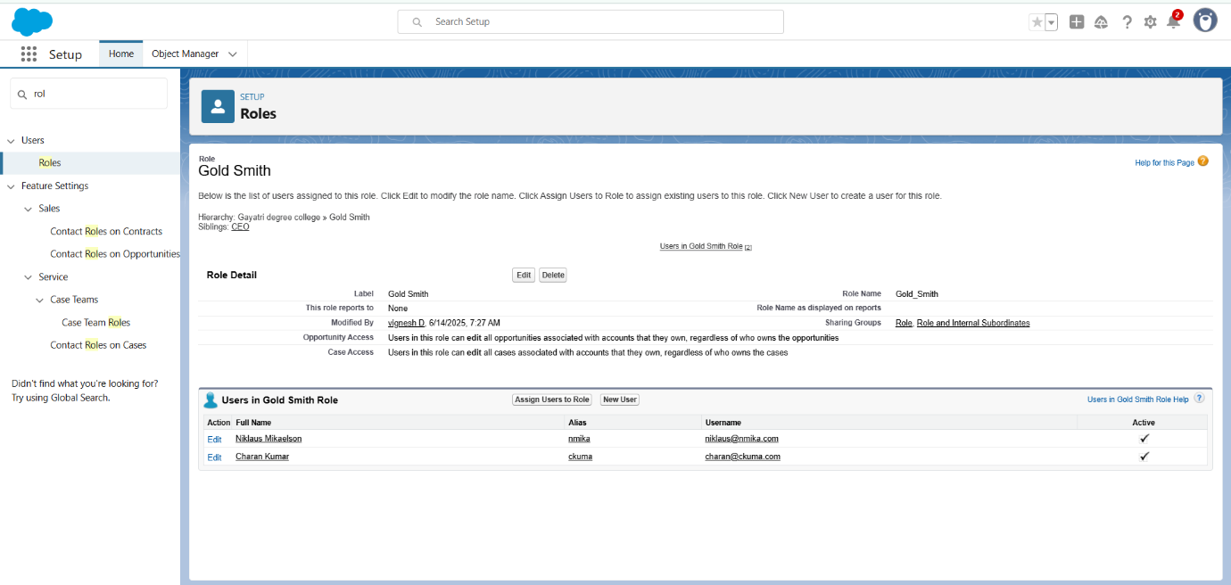

**Note: Create one more role as Worker which reports to Gold Smith.**

1. From setup >> Go to quick find >> Search for Roles >> click on set up roles.

2. Click on Expand All and click on add role under whom this role works.

3. Give Label as “Worker” and Role name gets auto populated. Check to whom

this role () reports. Then click on Save.

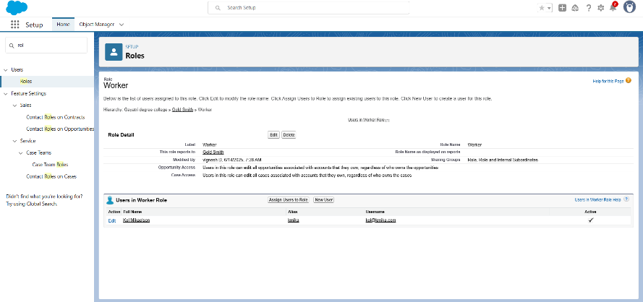

# MILESTONE-8

# Users

Create User

1. Go to setup >> type users in quick find box >> select users >> click New user.

2. Fill in the fields

1. First Name : Niklaus

2. Last Name : Mikaelson

3. Alias : Give a Alias Name

4. Email id : Give your Personal Email id

5. Username : Username should be in this form: text@text.text

6. Nick Name : Give a Nickname

7. Role : Gold Smith

8. User licence : Salesforce

9. Profiles : Gold Smith

10. Save.

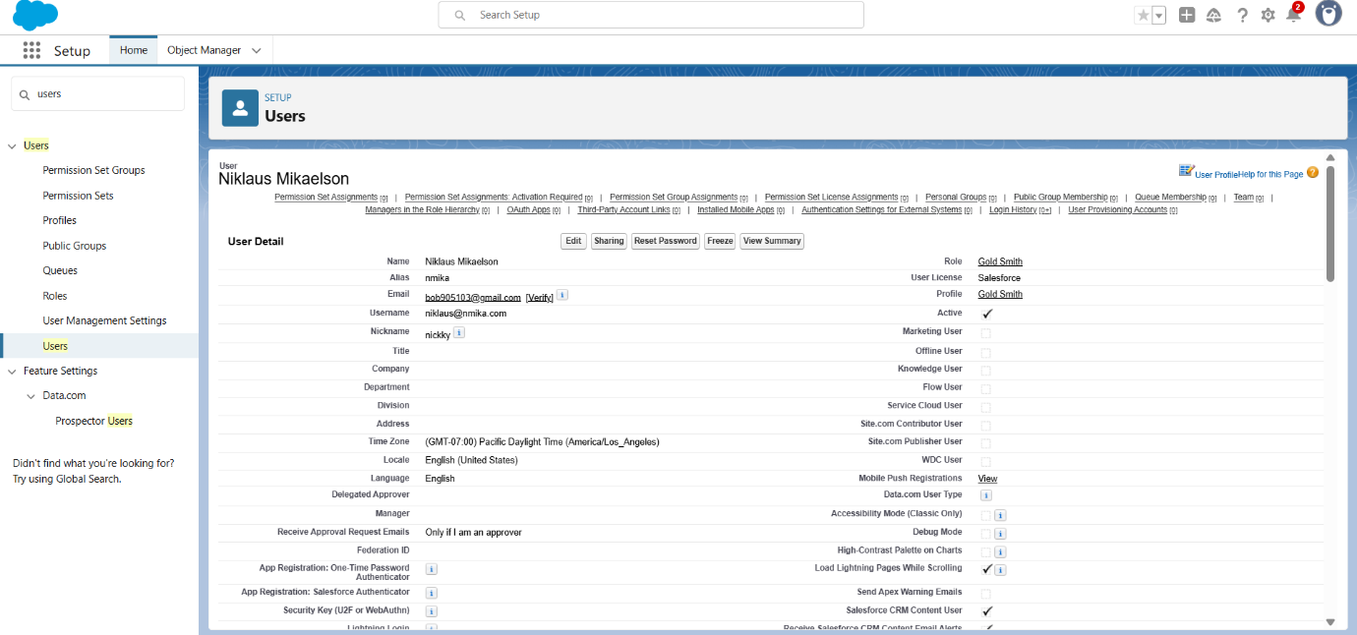

Create User

1. Go to setup >> type users in quick find box >> select users >> click New user.

2. Fill in the fields

1. First Name : Kol
2. Last Name : Mikaelson
3. Alias : Give a Alias Name
4. Email id : Give your Personal Email id
5. Username : Username should be in this form: text@text.text
6. Nick Name : Give a Nickname
7. Role : Worker
8. User licence : Salesforce Platform
9. Profiles : Worker

3. Save.

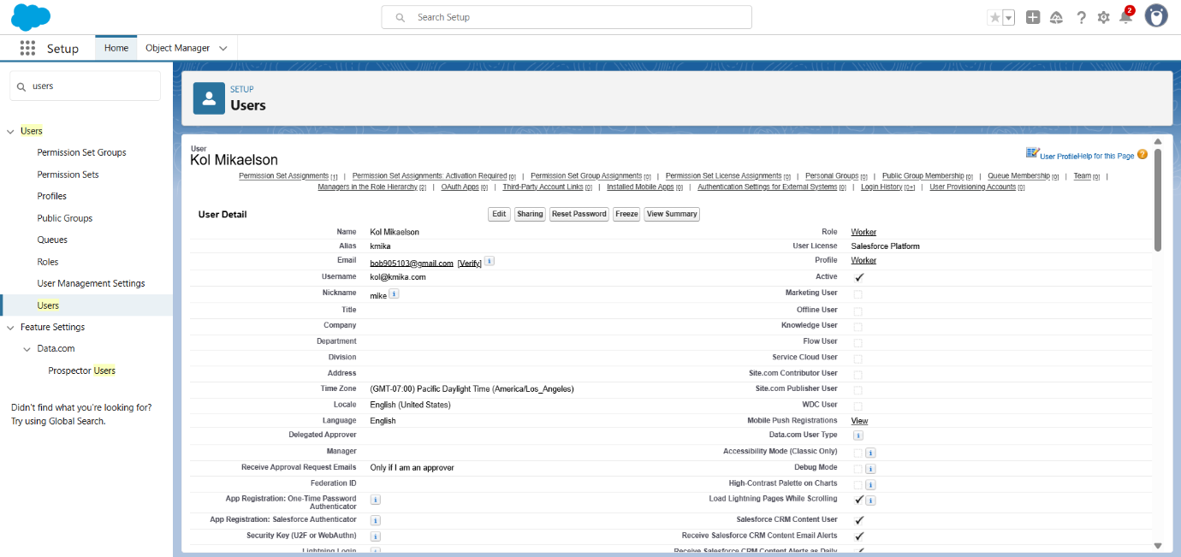

**Note: Create One more users as mentioned in activity 2 using the same profile.**

# MILESTONE-9

# Page Layouts

To Create a Gold Page layout

1. Go to Setup >> Click on Object Manager >> Search for the object (Item) >> From

drop down click on Edit.

2. Click on Page layout >> Click on New.

3. Give Page layout Name as “Page Layout for Gold” and click on Save.

4. Arrange the field as shown in the Information Section ,remove fields which are

related to Silver and click Ok.

5. Click Save.

6. Make sure your page layout looks like the picture above**.**

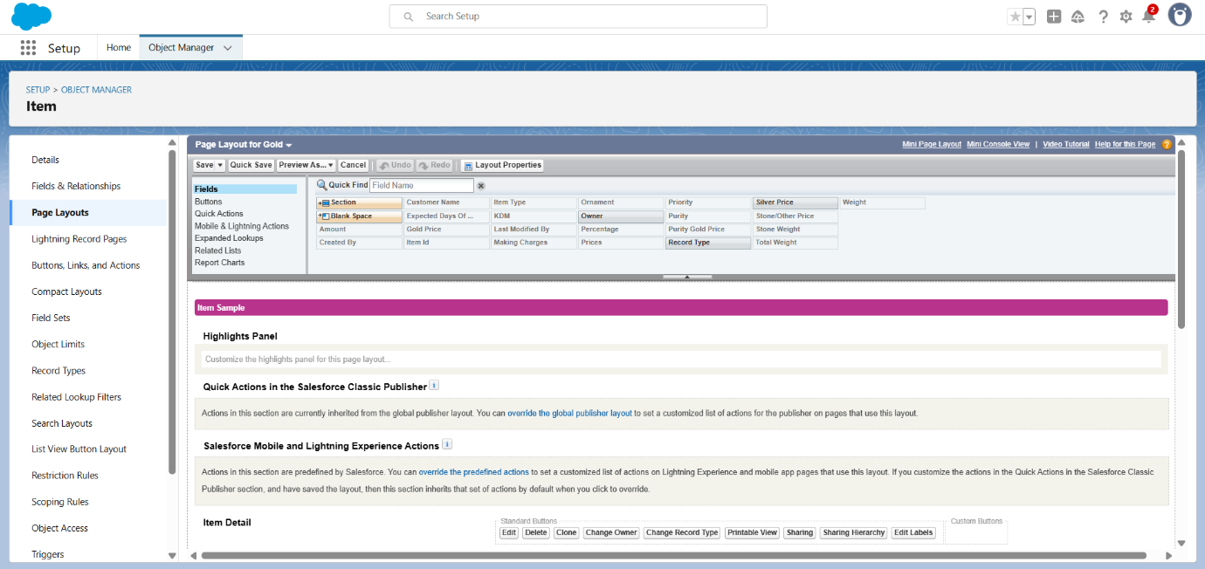

To Create a Silver Page layout

1. Go to Setup >> Click on Object Manager >> Search for the object (Item) >>

From drop down click on Edit.

2. Click on Page layout >> Click on New.

3. Give Page layout Name as “Page Layout for Silver” and click on Save.

4. Arrange the field as shown in the Information Section ,remove fields which are

related to Gold and click Ok.

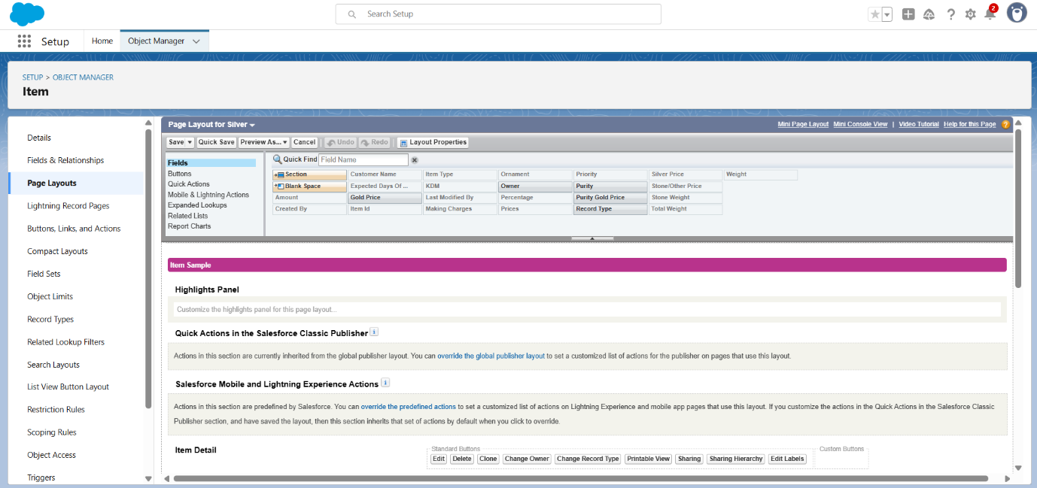

# MILESTONE-10

# Record Types

To create a Record Type

1. Go to setup >> click on Object Manager >> type object name (Item) in quick find

bar >> click on the object.

2. Click on the Record Types >> click New.

3. Select Existing Record as “Master”, Record type Label as “Gold”, Description as

“Gold items information”.

4. Uncheck for “Make Available”.

5. Scroll down and check for the Gold Smith, Worker & System Administrator profile

and click on Next.

6. Select “Apply a different layout for each profile”, and change page layout to “Page

Layout for Gold“ for Gold Smith, Worker and System Administrator >> save & new.

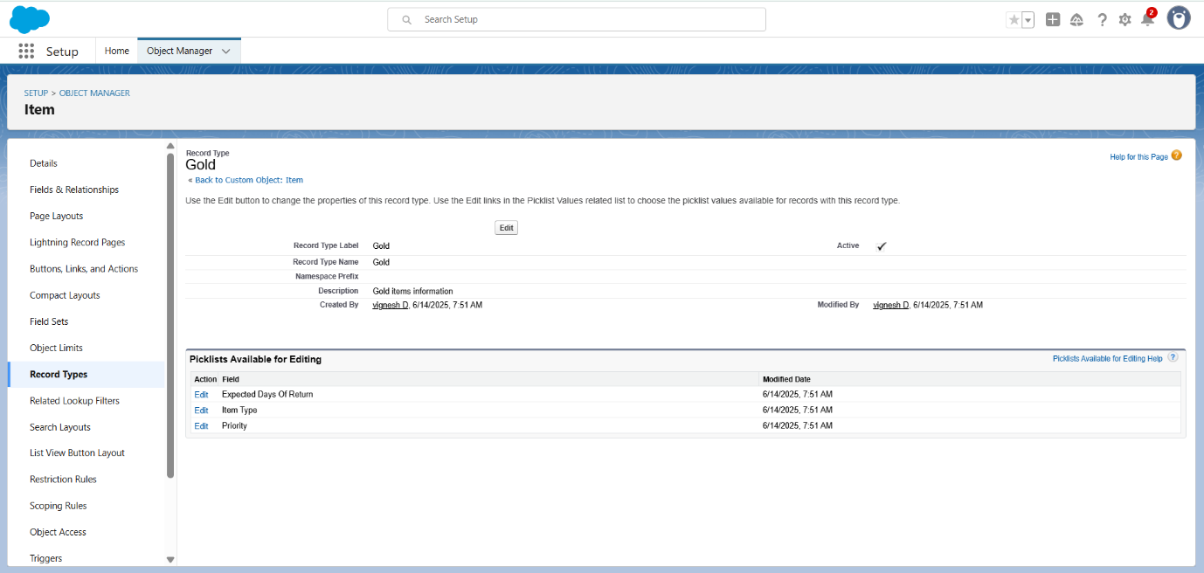

**Note:Create another Record Type with name “Silver” following the steps from Activity1**

**( Use page layout for Silver).**

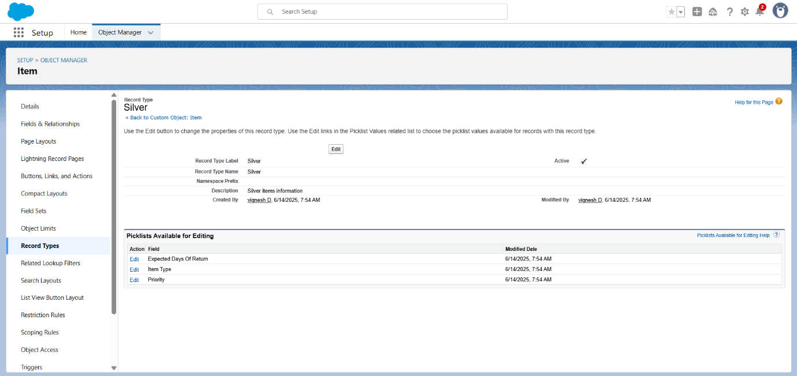

# MILESTONE-11

# Permission Sets

Creating permission set

A permission set is a collection of settings and permissions that give users access to

various tools and functions. Permission sets extend users' functional access without

changing their profiles. Users can have only one profile but, depending on the

Salesforce edition, they can have multiple permission sets.

1. Go to setup >> type “permission sets” in quick search >> select permission sets

>> New.

2. Enter the label name as “Per to Worker”, API will be auto populated >> save.

3. Under Apps Select object settings.

4. Click on Items object >> click on Edit >> under Item: Record Type Assignments,

enable Gold, Silver >> Object permission check for read ,edit and create.

5. Click on Save.

6. After saving the permission click on the Manage assignment

7. Now click on the Add Assignment.

8. Now select the users which you have created in user milestone, using Worker

profile and click on Next >> Assign >> Done.

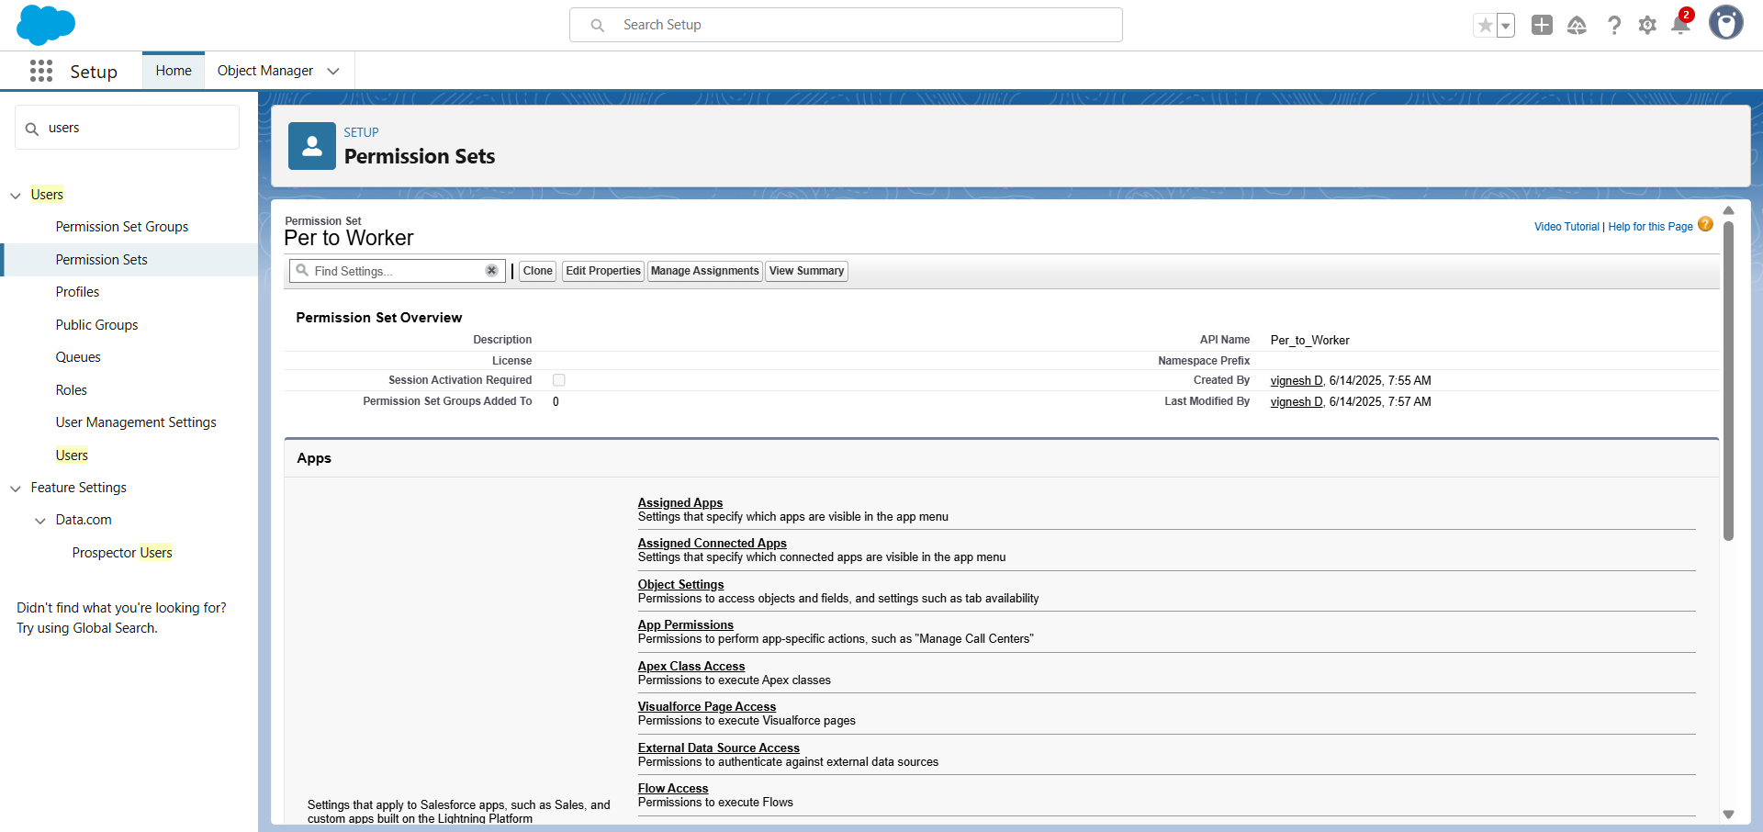

# MILESTONE-12

# Trigger

**NOTE : create “Paid Amount”, ”Paying Amount “ fields before create trigger.**

**Creating Currency(Paid Amount) Field in Billing Object**

To create fields in an object:

1. Go to setup >> click on Object Manager >> type object name (Billing) in quick

find bar >> click on the object.

2. Now click on “Fields & Relationships” >> New.

3. Select Data type as “Currency” and click Next.

4. Enter Field Label as “ Paid Amount” and length as “ 18 ”and decimal” 0 “.Field

name will be auto generated.

5. Click Next >> Next >> Next >> Save .

**Creating Formula(Paying Amount) Field in Billing Object**

1. Go to setup >> click on Object Manager >> type object name (Billing) in quick find

bar >> click on the object.

2. Now click on “Fields & Relationships” >> New.

3. Select Data type as “Formula” and click Next.

4. Give Field Label and Field Name as “Paying Amount” and select formula return type

as “Currency” and Decimal as ” 2 ” and click next.

5. Under Advanced Formula write down the formula : Total_Amount__c -

Paid_Amount__c

6. click “Check Syntax” and Next >> Next >> Save & New.

**Create a Trigger Handler class**

**Trigger handler:**

A trigger handler is a design pattern that organises trigger logic into separate classes.

This helps in keeping code organised, reusable, and easier to maintain. The trigger

handler class contains methods that handle the specific logic for different trigger

events, improving code structure and readability. This approach is particularly useful

for complex triggers or projects with multiple triggers, as it promotes modular coding

practices and reduces the chances of code duplication.

1. Click the Gear icon >> click on Developer Console >> File>>New >>Apex class.

2. Give name for your new Apex class as “UpdatePaidAmountTriggerHandler >>”ok”.

3. Paste the code given below.

CODE:

*public class UpdatePaidAmountTriggerHandler {*

*public static void handleBeforeInsert(List<Billing__c> newBillings) {*

*for (Billing__c billing : newBillings) {*

*billing.Paid_Amount__c = billing.Paying_Amount__c;*

*}*

*}*

*public static void handleBeforeUpdate(Map<Id, Billing__c> oldBillingsMap,*

*List<Billing__c> updatedBillings) {*

*for (Billing__c billing : updatedBillings) {*

*Billing__c oldBilling = oldBillingsMap.get(billing.Id);*

*Decimal oldPaidAmount = oldBilling.Paid_Amount__c;*

*billing.Paid_Amount__c = oldPaidAmount + billing.Paying_Amount__c;*

*}*

*}*

*}*

**Create the trigger :**

1. Click the Gear icon >> click on Developer Console >> File>>New >>Apex Trigger.

2. Give name for your new Apex class as “UpdatePaidAmountTrigger >>”ok”.

3. Paste the code given below.

**CODE:**

*trigger UpdatePaidAmountTrigger on Billing__c (before insert, before update) {*

*if (Trigger.isInsert) {*

*UpdatePaidAmountTriggerHandler.handleBeforeInsert(Trigger.new);*

*} else if (Trigger.isUpdate) {*

*UpdatePaidAmountTriggerHandler.handleBeforeUpdate(Trigger.oldMap,*

*Trigger.new);*

*}*

*}*

# MILESTONE-13

# User Adoption

Create a Record (Jewel Customer)

1. Click on App Launcher on the left side of the screen.

2. Search Jewelry Inventory System & click on it.

3. Click on Drop Down and Click on the Jewel Customer tab.

4. Click New.

5. Fill the Details and click on Save.

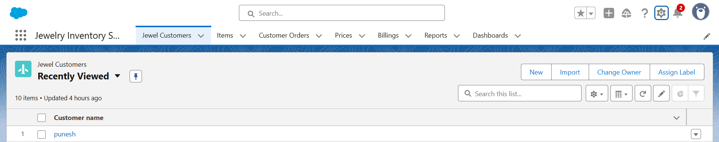

**View a Record (Jewel Customer)**

1. Click on App Launcher on the left side of the screen.

2. Search Jewelry Inventory System & click on it.

3. Click on the Jewel Customer Tab.

4. Click on any record name. you can see the details of the Jewel Customer.

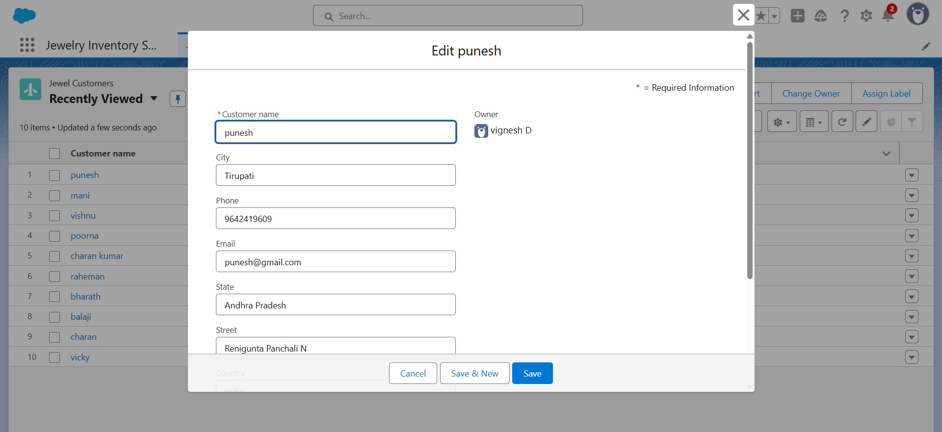

**Delete a Record (Jewel Customer)**

1. Click on App Launcher on the left side of the screen.

2. Search Jewelry Inventory System & click on it.

3. Click on the Jewel Customer Tab.

4. Click on Arrow at right hand side on that Particular record.

5. Click delete.

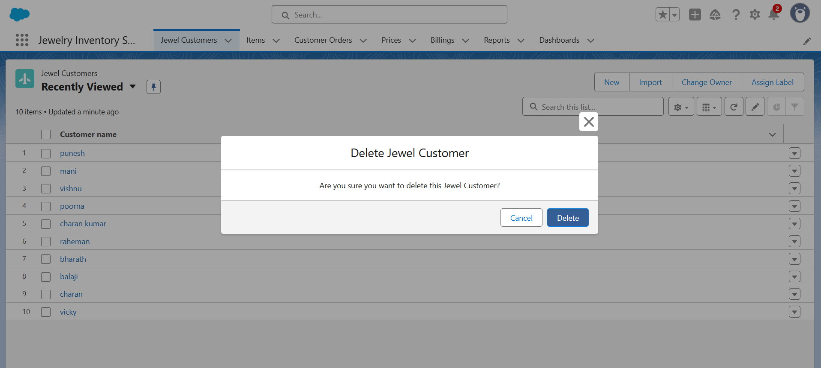

**Note: Create at least 10 records for each of the objects: Jewel Customer ,Price ,Item,**

**Customer Order and Billing.**

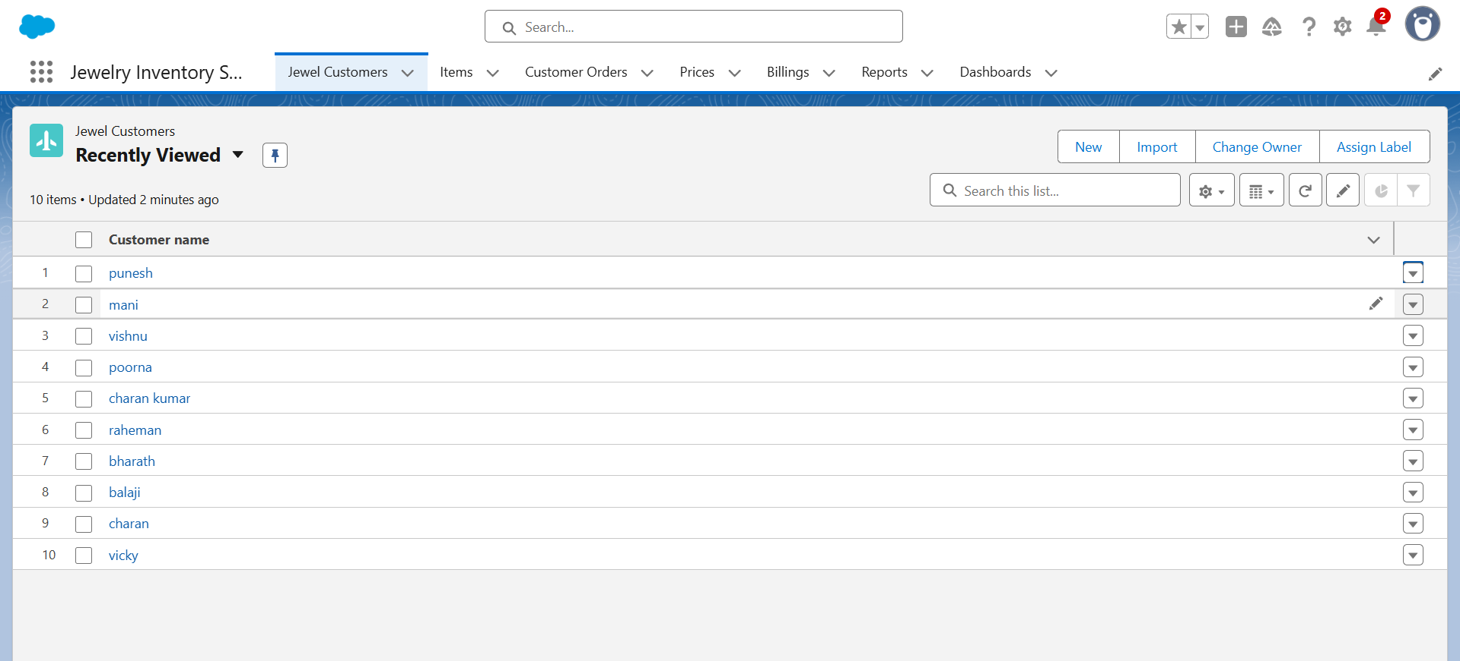

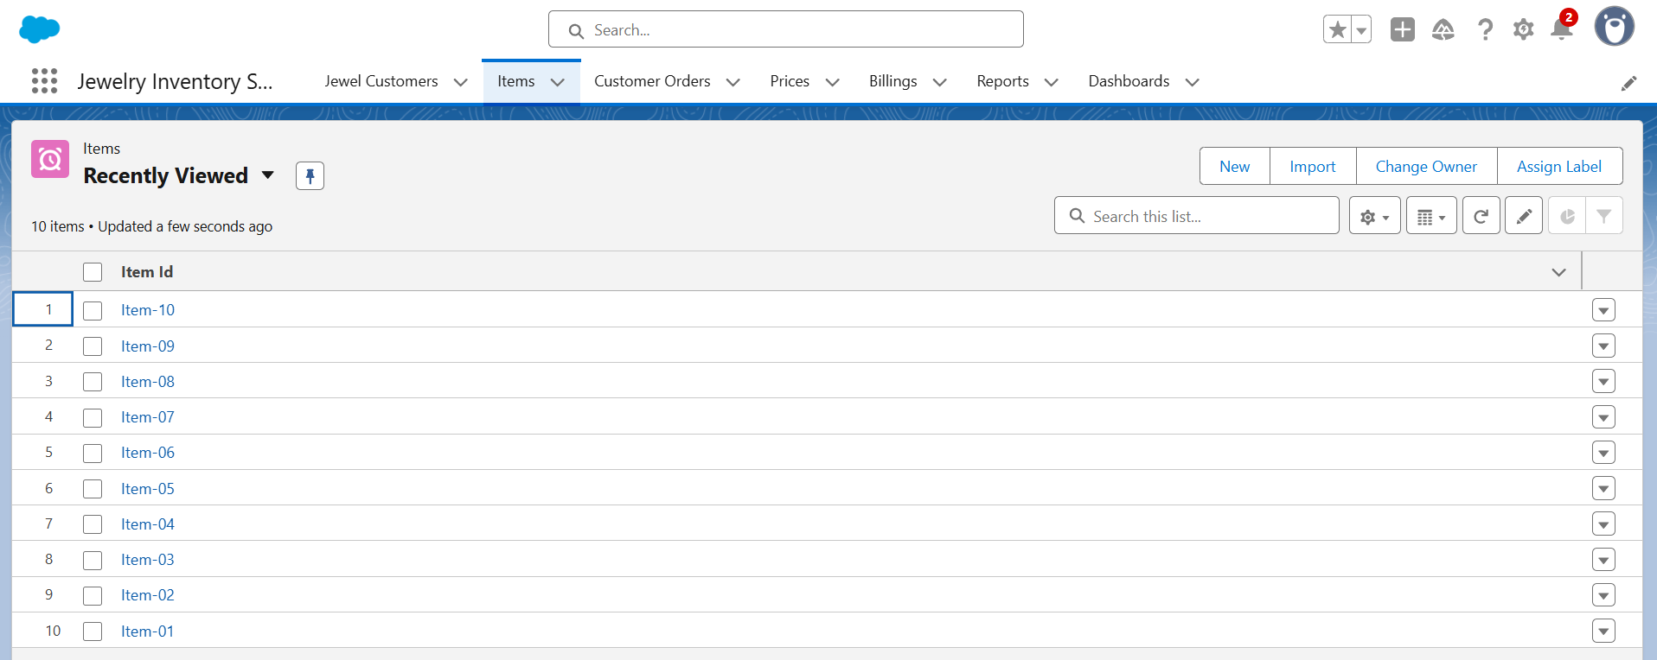

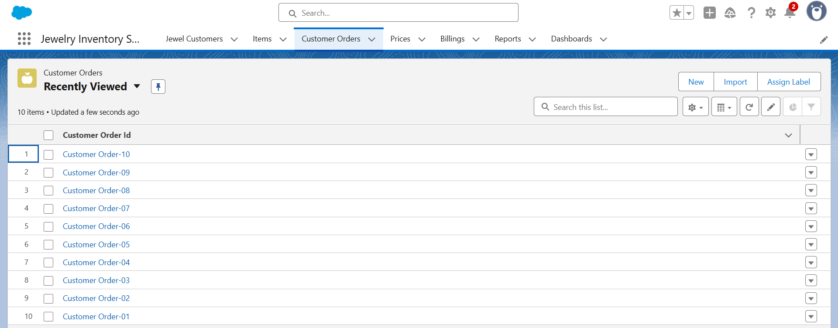

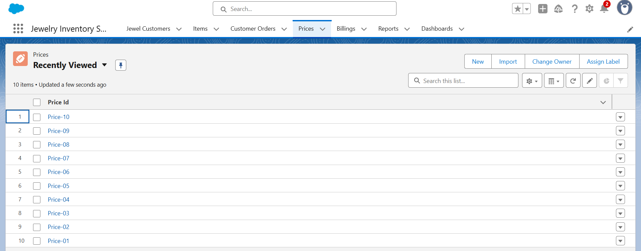

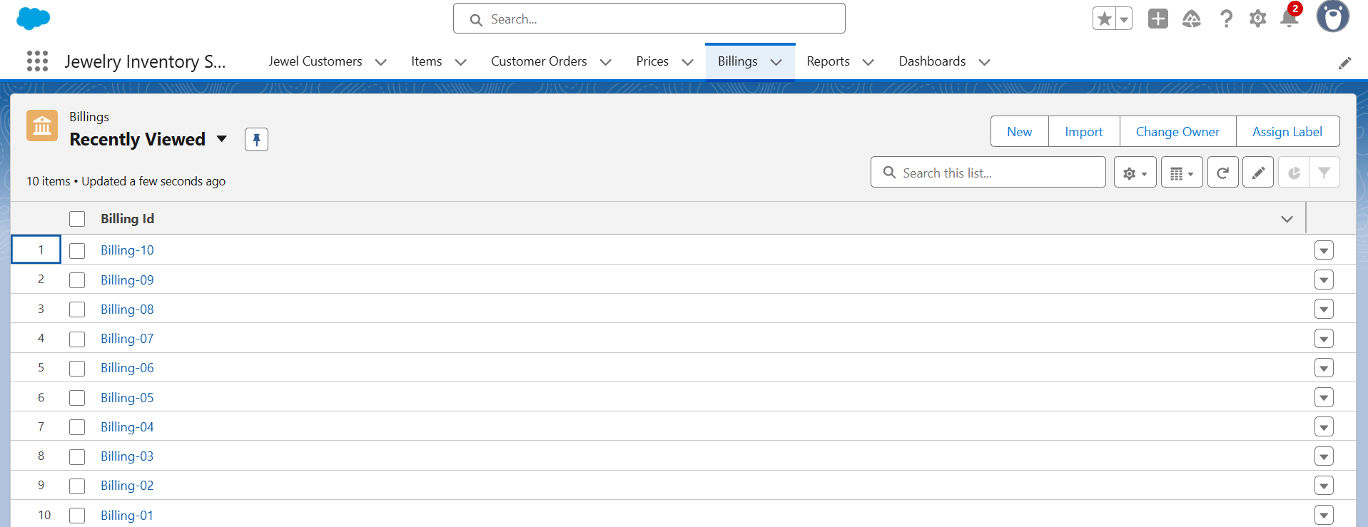

# MILESTONE-14

# Reports

**Create Report**

1. Go to the app >> click on the reports tab.

2. Click New Report.

3. Select report type (New prices report) from category or from report type panel

or from search panel >> click on start report.

4. Customise your report

* Add fields from the left pane as shown below.

5. Save or run it.

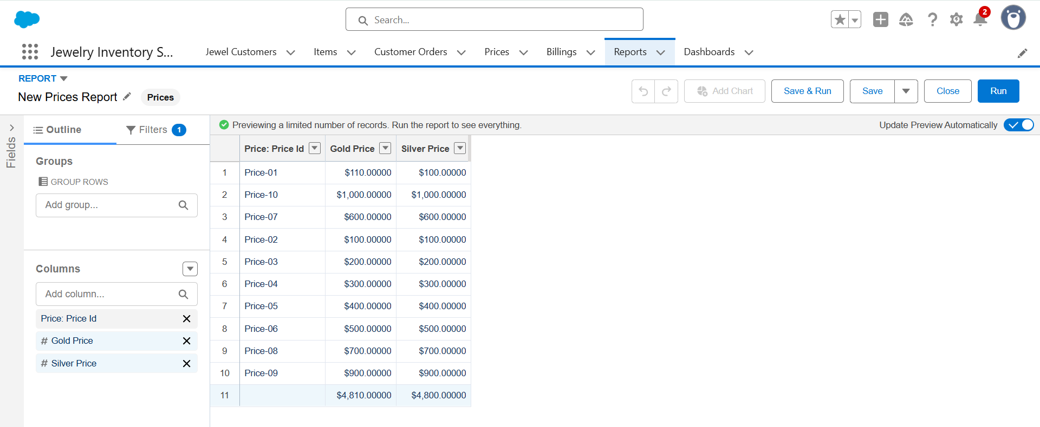

**Note:** create two more reports like [New Prices Report](https://orgfarm-b3ea0500f0-dev-ed.develop.lightning.force.com/lightning/r/sObject/00OgK000002nFcfUAE/view?queryScope=userFolders), [New Report](https://orgfarm-b3ea0500f0-dev-ed.develop.lightning.force.com/lightning/r/sObject/00OgK000002nFw1UAE/view?queryScope=userFolders)

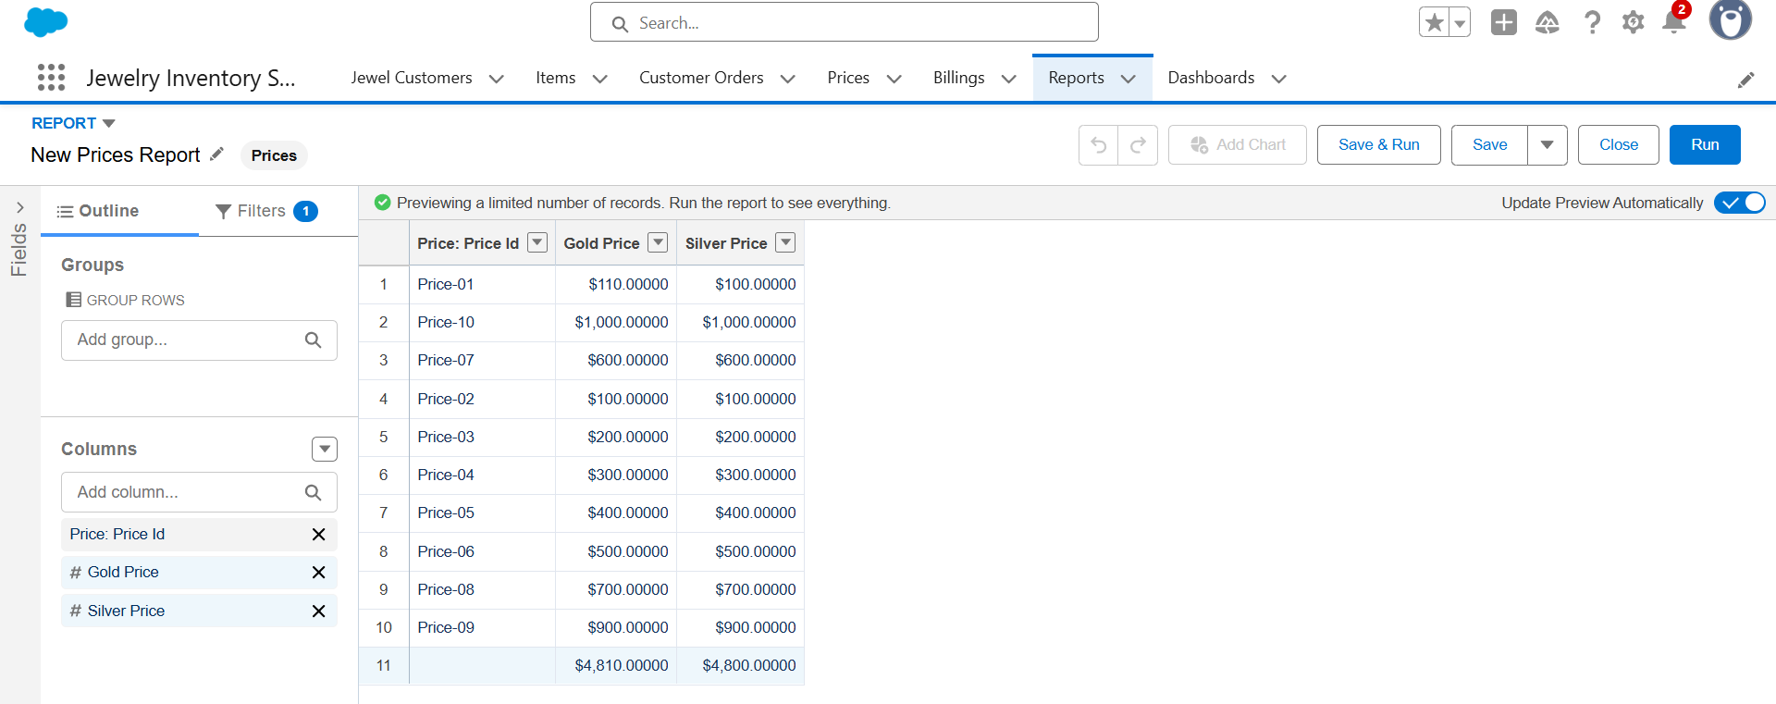

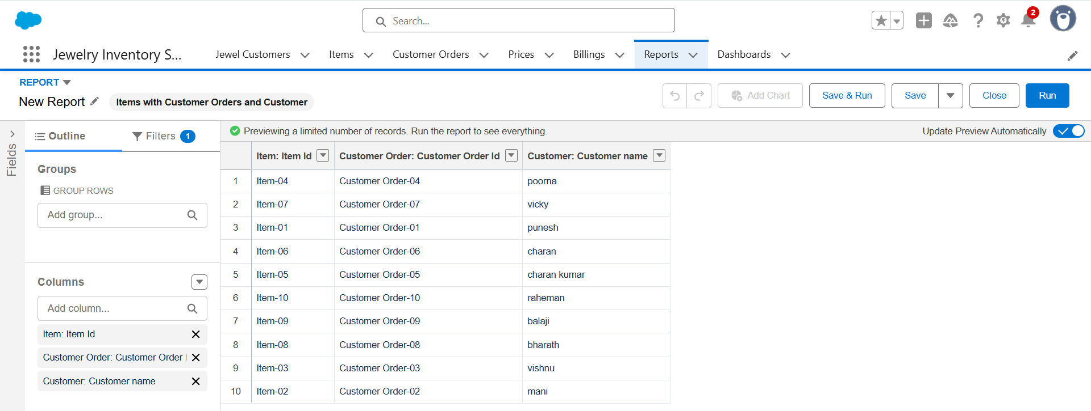

# MILESTONE-15

# Dashboards

**Create Dashboard**

1. Go to the app >> click on the Dashboards tabs.

2. Give a Name as ”Jewel Management” and click on Create.

3. Select add component.

4. Select a Report and click on select.

5. Click Add then click on Save and then click on Done.

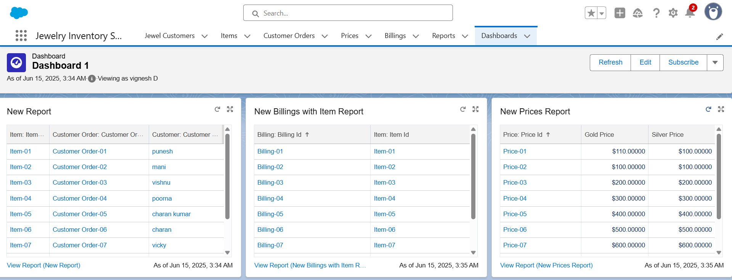

## MILESTONE-16

Flows

**Create a Flow**

1. Go to setup >> type Flow in quick find box >> Click on the Flow and Select the

New Flow.

2. Select the Record-triggered flow and Click on Create.

3. Select the Object as a “Billing” in the Drop down list.

4. Select the Trigger Flow when: “A record is Created or Updated”.

5. Select the Optimise the flow for: “Actions and Related Records” and Click on Done.

6. Now change the mode form Auto-layout to free-form.

7. Now select the manger option in the toolbox, click New resource.

8. Select the resource type as text template.

9. Enter the API name as “ Email body”.

10. Change the view as Rich Text >> View to Plain Text.

11. In the body field paste the syntax that is given below.

Hello

Customer Name: {!$Record.Item__r.Customer_Name__r.Name}

Here are the details for the item you purchased with Jewelry Inventory System

Item Type: {!$Record.Item__r.Item_Type__c}

Ornament: {!$Record.Ornament__c}

Weight: {!$Record.Weight__c}grams

Amount: {!$Record.Amount__c}

12. Click done.

13. Now click on elements, and drag the action element into the preview pane.

14. Their action bar will be opened in that search for “ send email ” and click on it.

15. Give the label name as “ notice”

16. API name will be auto populated.

17. Enable the body in set input values for the selected action.

18. Select the text template that was created.

19. Include Recipient Address list, select the email form the record.

({!$Record.Item_r.Customer_Namer.Email_c})

20. Include the subject as “Welcome to Jewelry Inventory System ”.

21. Click done.

22. Now drag the path from the start to the action element.

23. Click on save. Given the Flow label , Flow Api name will be auto populated.

24. And click on save and click Activate.

